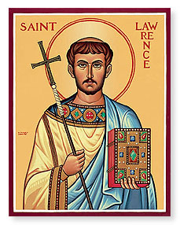 2018 Saint Lawrence Catholic Church Scholarship Application
*To be awarded to High School Seniors who attend St. Lawrence Catholic Church
- Name ______________________________
- Address____________________________
- Telephone __________________________
The following scholarship criteria should be met to be considered for the award: (each criteria percentage weighted)
- Proof of completion of Confirmation (50%)
- Proof of 75 hours of church and/or community service performed between grades 10 thru 12. (30%) Service hours can include *Corporal Works of Mercy in the community and scouting projects. Church service can include CCD assistance, Thrift Store volunteer, church grounds help such as mowing or snow removal, help with church functions such as Fall Festival, volunteering time with Knights of Columbus or Sunshine Club. Other community or church service not mentioned will be considered on an individual basis. (If you do not have 75 service hours please submit the hours that you have performed)
- Proof of High School Grade Point Average of 3.0 (10%)
- Proof of acceptance in 2 or 4 year college or technical school (10%)
- Submission of 500 word essay describing how your faith as a Catholic will help you be successful in school, in your career and in achieving your life goals. Essay must be submitted in English.
- Scholarship recipients will be required to share the impact this scholarship reward had for them 1 year later during a designated mass.
Please attach all documentation to this form and return to any of the individuals listed below after any 11:15 Sunday Mass:
Renee Burkley, Connie Juaregui, Julianne Wunder
Questions email rlburkley@gmail.com
All Applications due by April 30th GOOD LUCK!
*Corporal Works of Mercy: To feed the hungry, to give drink to the thirsty, to clothed the naked, to shelter the homeless, to visit the sick, to visit the imprisoned, to bury the dead.

