Our Lady of Perpetual Help Parish
Reflection on and Evaluation of Confirmation Preparation

PRAYER – prayer is opening oneself up to God both in words and silence with scripture and with others. In my preparation for Confirmation, what was the best prayer experience you’ve had so far this year?

Please describe it and how did it make you feel?
EUCHARIST – Eucharist is center of a Catholic’s life. Everything we are and do comes from our giving thanks to God. Has your preparation for Confirmation changed your view of Mass? Why or why not and if so, how?

STEWARDSHIP & SERVICE – A disciple of Jesus realizes everything we have is a gift and always gives thanks, especially by serving others and contributing to the Church. During my preparation for Confirmation, the best experience I had while serving others was (and describe it)
Just because you may have completed your required hours of service doesn’t mean that you should stop helping others. As Christians we are always called to help others. How do you see yourself helping others in the future?

PERSONAL GROWTH – as young person I am called to be responsible, to develop my Christian character, and to grow in the Gifts of the Holy Spirit. During your preparation for Confirmation, how have you changed/grown? Describe how

~ OVER ~

Page 29

KNOWLEDGE OF THE FATIH - We keep growing in our understanding of God, the Church and the world.

Can you name something that you LEARNED this year that you didn’t know before? Describe

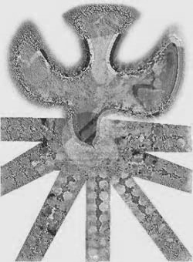
SPONSOR RELATIONSHIP
Who is your sponsor?

How do you know this person?

Why did you choose this person to be your sponsor?
How do you see your relationship with this person in the future? Describe it.

GOAL The goal of our Confirmation Program at Our Lady is to conform ourselves to Christ, to take on the attitude of Christ as a life-long journey.

_____ I have prepared seriously and request Fr. Daprile to recommend me to
Bishop George Murry to receive the Sacrament of Confirmation.
_____ I am not ready to receive the Sacrament of Confirmation

Candidate Signature

Print your name
Date__________________

Accepted by Fr. Daprile
Page 30

