Nombre: ________________________ Clasé: _____________

3rd Grade:
(Unit 2- Week 1) STUDY GUIDE

Exámen: Wednesday, 11-6-19

Vocabulary: Study your vocab list to know what these mean in English

comunidad ¡Bienvenido!
ciudad hermoso
campo visitan
vive lugar
¿Dónde está?

Spelling: Be able to spell these “house” words in Spanish

house= casa (pronounced KA-SAH)
bathroom= baño (pronounced BAN-YO) HINT: remember the ~
kitchen= cocina (pronounced CO-SI-NA)
dining room= comedor (pronounced CO-MEH-DOOR)
bedroom= dormitorio (pronounced DOOR- MEH- TORIO)
living room= sala (pronounced SA-LAH)

Fill in the Blank: Remember what the sentence means and the underlined word.

Anna y Charlie están en la cocina. (Anna and Charlie are in the kitchen.)
Camila vive en la ciudad. (Camila lives in the city.)
¿Dónde están Ana y Charlie? (Where is Anna and Charlie)
La casa de Camila es hermosa. (Camila’s house is beautiful.)

Translate to English: Study homework pg. 21
La máma está en la sala.
Las niñas estan en la cocina.
El niño está en el baño.
Los niños están en el dormitorio.

Drawing: Be able to draw ONE room in a house and label the it in Spanish:
For example:
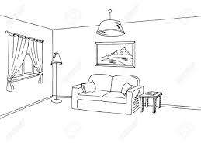= la sala

