Nombre: __________________ Clasé: _________

4th Grade:
(Unit 3- Week 3) STUDY GUIDE

Exámen: Wednesday, 3-10-21

VOCABULARY: Study your vocab list to know what these mean in English

celebración (celebration) hacer (to do/ make)
gimnasio (gym) tocar (to play)
guitarra (guitar
puedo (I can)

SPELLING: Be able to spell these “sports” words in Spanish

golf= golf (pronounced GO-OLF)
Practice
________________________
________________________
________________________

tenis= tennis (pronounced TE-NEES)
Practice:
________________________
________________________
________________________

fútbol americano= football (pronounced FOOTBOL- AMERICANO)
Practice:
________________________
________________________
________________________

natación= swimming (pronounced NAH-TA-SEE-ON)
Practice:
________________________
________________________
________________________

gimnasia= gymnastics (pronounced HIM-NA- SEE- AH)
Practice:
________________________
________________________
________________________

básquetbol= basketball (pronounced BAS-KEET- BOL)
Practice:
________________________
________________________
________________________

béisbol= baseball (pronounced BEH-EES- BOL)
Practice:
________________________
________________________
________________________

fútbol= soccer (pronounced FOOT-BOL)
Practice:
________________________
________________________
________________________

GRAMATICA:
A. Correct these sentences with proper Spanish punctuation. (see HW pg. 40)

¿Adíos? = Goodbye!
Answer= ¡Adíos!

Tengo que estudiar.= I have to study!
Answer= ¡Tengo que estudiar!

B. Oragnize these sentences correctly in Spanish.

1. niño El toca guitarra. la (The little boy plays the guitar.)
ANSWER= El niño toca la guitarra.

2. béisbol! divertido ¡Es jugar (It’s fun to play baseball!)
ANSWER= ¡Es divertido jugar béisbol!

Comprehension: Use and study “invitation” from homework pg. 41

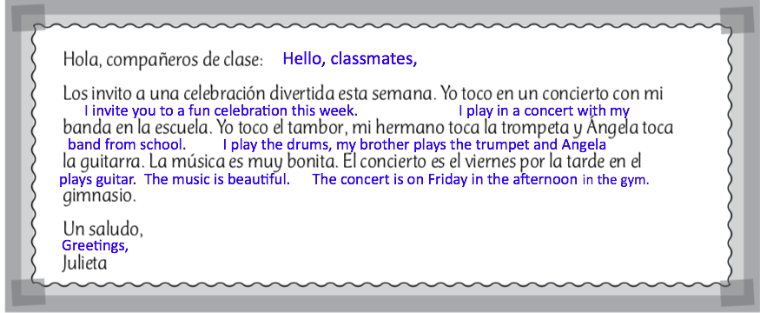

Write the words from this “invitation” that are similar both in English and Spanish.

1.
2.
3.
4.
5.
6.
7.
8.

Hablar (Speaking): “¿Que te divierte?” – What do you enjoy (do for fun)?

Say whether you enjoy a sport or not in Spanish. Use any sport from our vocabulary list.

Examples:

Me divierte béisbol. (I enjoy baseball.)

OR

No me divierte béisbol. (I don’t enjoy baseball.)

