**Instructions for viewing/printing payment history for a tax year.**

**Step 1:** FACTS Customer will sign into FACTS at [https://online.factsmgt.com](https://online.factsmgt.com/)

**Step 2:** Select ‘View Details’

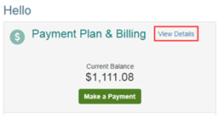

**Step 3:** Select ‘View Payment Summary’

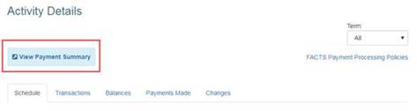

\*\**Page will open in another window or tab.*\*\*

**Step 5:** Select the year & then ‘Print’.

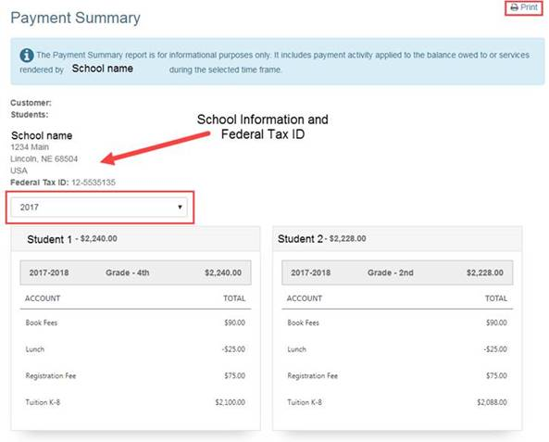

**NOTE:** *This report will show the total paid for* ***each of the accounts*** *(i.e. Tuition, Extended Day Care, Technology, Book fees, etc.). The parents can select a year or a date range for this summary. This will also include the Schools Federal Tax ID and address.*

If your families have any questions, please have them call FACTS at 866-441-4637.