The Celebration of the
Sacrament of Marriage
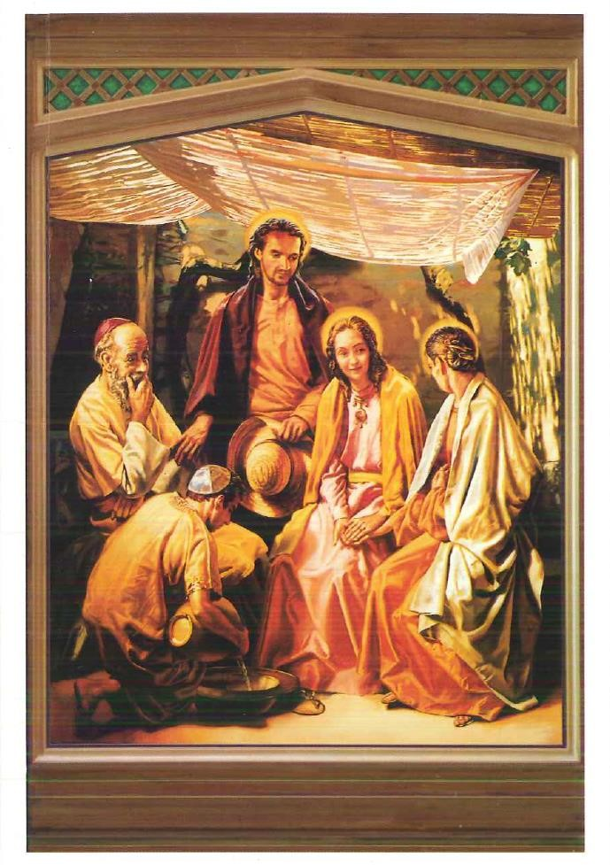

“The sacrament of Matrimony signifies the union of Christ and the Church. It gives spouses the grace to love
each other with the love with which Christ has loved His Church; the grace of the sacrament thus perfects the
human love of the spouses, strengthens their indissoluble unity, and sanctifies them on the way to eternal life.” (Catechism of the Catholic Church 1661)

Dear Wedding Couple,
I welcome you and share in your joy as you prepare to receive the Holy Sacrament of Marriage. Your wedding symbolizes a new beginning in your lives. As Baptism begins the life of grace in the soul, marriage begins a new chapter in your lives as you prepare your hearts and souls for the new graces that Christ is preparing for you.
In marriage, a husband and wife have the incredible potential to reflect the love of the Most Blessed Trinity. However, through the love shared in marriage, you also have the ability to help each other grow in holiness, to welcome and educate any children with which our Lord may bless you, to become the saints our Lord calls each of us to be, and, ultimately, assist one another in attaining the glory of Heaven.
The grace proper to the Sacrament of Marriage is intended to perfect your love and to strengthen the indissoluble unity of your future marriage. Jesus Christ is the source of this grace. In receiving this sacrament, He will dwell with you both. He will give you the strength to take up your crosses and so follow Him, to rise again after you have fallen, to forgive one another, and to bear one another’s burdens. As St. Paul writes, you will be able to “be subject to one another out of reverence for Christ” and to love one another with supernatural, tender, and fruitful love. In the joys of your love and family life, He will give you here on earth a foretaste of the wedding feast of the Lamb in Heaven.
May our Lord Jesus Christ bless you both with His Love and His Grace, and may He strengthen you both as He prepares to touch your hearts and souls in a new and most beautiful way.
Yours in Christ Jesus,
Rev. Carl E. Beekman
Pastor
St. Anthony Catholic Church
Rockford, IL.

Requirements for Marriage
The Code of Canon Law states that “The matrimonial covenant, by which a man and a woman establish between themselves a partnership of the whole of life, is by its nature ordered toward the good of the spouses and the procreation and education of offspring; this covenant between baptized persons has been raised by Christ the Lord to the dignity of a sacrament.” In these next sections, the various requirements are listed and necessary for completion in order to be married here at this Catholic Church.

Church Requirements
- Both the bride and the groom must be free to marry. That is to say, you must not have been married before (unless widowed). If either party has been previously married, whether you are Catholic or not, you must possess either a Declaration from Lack of Form or Decree of Invalidity (otherwise known as an annulment) from the Roman Catholic Church. Any investigation is required before the wedding date can be set.
- To show the care and concern of the Church toward those entering the Sacrament of Marriage, and to preserve the dignity, sanctity and respect deserving of this Sacrament, a program of sacramental preparation is required. Arrangements should be made with the priest as to what program is most appropriate for the individual couple. This preparation is best completed well in advance of the wedding.
- A Baptismal certificate less than six (6) months old must be submitted by each Catholic party. In an interfaith marriage, the non-Catholic, if baptized, should also present a record of Baptism.
- Two witness affidavits affirming each party’s freedom to be married must be submitted.
- The Prenuptial Questionnaire for both the bride and the groom must be completed with the priest or deacon.
- A dispensation is required in all interfaith marriages and will be completed at the parish office four months before the wedding.
- Each couple has to attend a Gift of Self Seminar as per the directives of the Diocese of Rockford, and be able to provide documentation of this training prior to their wedding, at least two months prior to their wedding day.
- It is appropriate for the bride and groom to prepare themselves for the celebration of their marriage by receiving the Sacrament of Penance if they are Catholic.

Parish Requirements
- All parish arrangements and documentation must be completed at least one month before the wedding date.
- The resident priest responsible for your parishes are to be those who generally perform all weddings for our parishioners. A guest priest or deacon is permitted to perform the wedding ceremony. However, the permission of the Pastor must be obtained. Visiting clergy have to be in good standing with the Catholic Church, and have obtained permission by the Pastor, as well as the Diocese of Rockford to illustrate the fact that he does have appropriate faculties for the Diocese of Rockford, as well as in his own Diocese. It is expected that the guest priest or deacon attend and perform the wedding rehearsal.

Civil Requirements
A Marriage License must be obtained within sixty (60) days prior to the wedding from the Winnebago County Clerk’s Office.

Marriage License
Winnebago County Marriage License Information
Where can couples in Rockford, Illinois apply for a marriage license?
Couples in Rockford, Illinois can apply for a marriage license at the Winnebago County Clerk’s office, which is located in Suite 104 at 404 Elm Street in Rockford, Illinois. Office hours are from 8:00 a.m. to 5:00 p.m. Monday through Friday. Couples must appear at the office together in person, submit a marriage license application, present I.D. and pay the marriage license fee in order to be issued a marriage license.

What are the requirements to be issued a marriage license in Rockford, Illinois?
To be issued a marriage license in Winnebago County, both applicants need to be single, members of the opposite sex, and at least 18 years old. Close blood relatives will not be issued a marriage license unless both applicants are over the age of 50. Minors must have parental consent in order to be issued a marriage license in Winnebago County. There are no residency requirements for marriage licenses in Winnebago County.

What documents should couples bring when they go to apply for a marriage license at the Winnebago County Clerk’s office?
Both applicants should bring a valid form of I.D. such as a driver’s license or a passport when they go to apply for a marriage license at the Winnebago County Clerk’s office.

What is the standard marriage license fee in Rockford, Illinois?
The marriage license fee in Rockford, Illinois is $20.00. Couple must pay the fee with cash at the Winnebago County Clerk’s office at the time that they submit their marriage license application.
Age Requirements:
Both parties must have attained the age of 18 years at the time the marriage license is effective or will have attained the age of 16 years and have either the consent to the marriage of both parents or their guardian or judicial approval.
Proof of Age:
Applicants who are 18 years of age and under must present their birth certificate as proof of age.
Medical Examination: None required.
Identification:
Photo ID is required for both parties.

Non Residents:
Non-residents must comply with the requirements of their respective states. Non-residents requiring consent of parents or legal guardian must obtain a consent sworn to before the COUNTY CLERK or a NOTARY PUBLIC.

Parish Policies for Weddings
To enable a joyful and reverent celebration of your wedding, the following requirements must be met for reasons of safety as well as preservation and maintenance of our church facilities.
- We ask that you please keep these areas of the church neat as well as the entire church facility.
- Due to safety and trip hazards, white aisle runners are allowed but not encouraged when the center isle is stone.
- Arrangements for flowers are to be made by the bride and groom with the florist of their own choice. Selection of additional church decorations should be made in consultation with the parish priest. Please read the section intended for the florist and give it to the florist you have hired.
- Arrangements for photographs are to be made by the bride and groom with the photography studio of their own choice.
Please read the handout (see page 20 of this document) which is intended for the photographer / videographer and give it to the studio you have hired. If need be, copy page 20 and ensure that they know what is required.

- Unity candles are not a part of the Catholic tradition of celebrating this beautiful Sacrament of Marriage. The Wedding Reception is the appropriate place for the Unity candles.
- Flower petals are allowed to be dropped in the church, ONLY if the florist has made arrangements for them to be picked up immediately after the ceremony.

- Balloons are not allowed anywhere inside the church building. Out of respect for the environment, we ask that you check with local city ordinances with regard to the releasing of balloons outside.

- The throwing of rice, bird seed, confetti, and anything of this nature is not allowed anywhere on the church premises, both inside and outside, as it creates a safety hazard for guests as well as for those attending the Saturday evening Mass, also it involves a great deal of clean-up. Janitorial help is not available at the time of your wedding. Bubbles are the ideal substitute for rice as the bride and groom walk out of the church.

Alcohol, Smoking, and Gum Chewing
- There is to be NO alcohol consumed in the church or on the church grounds before, during or after the wedding. This includes the parking lot.
- Any member of the wedding party (the bride and the bridal party, the groom and his groomsmen, readers, ushers, or any guests for that matter) who come to the wedding and appear to have been drinking, or who has had too much to drink, will not participate in the wedding and will be asked to leave. If necessary, the priest or deacon may cancel the wedding.
- No smoking is allowed anywhere in the church building.
- There is to be no food, gum / candy, or drink in the church before, during, or after the wedding and also during the time of taking pictures.

Wedding Times
Saturday 1:00 PM
The Parish has reserved the use of the church on Saturday afternoons for weddings. Other times are available and can be arranged with the priest. Sundays and Saturday evenings are not allowed. Please note that some Saturdays may be closed due to holy days or large parish events. We appreciate your understanding.

Wedding Rehearsals
Rehearsals are usually scheduled for an evening (usually Friday evening at 5:00 pm) during the week before the wedding, and should be scheduled four months in advance. It is important that all who have an active part in the wedding Mass or ceremony attend so that each one understands their part. This would ordinarily include the bridal party, ushers, and those who will be doing the readings.
Out of courtesy to those involved, please be on time. This is a busy time for all involved and promptness helps a great deal.

Planning the Wedding
Depending upon the religious backgrounds of both parties, there are two options available for the celebration of Marriage
1. The Rite of Marriage outside of the context of a Catholic Mass
2. The Rite of Marriage within the context of a Catholic Mass.

The Catechism of the Catholic Church teaches, “In the Latin Rite the celebration of marriage between two Catholic faithful normally takes place during Holy Mass, because of the connection of all the sacraments with the Paschal mystery of Christ. In the Eucharist the memorial of the New Covenant is realized, the New Covenant in which Christ has united himself for ever to the Church, His beloved bride for whom He gave Himself up. It is therefore fitting that the spouses should seal their consent to give themselves to each other through the offering of their own lives by uniting it to the offering of Christ for His Church made present in the Eucharistic sacrifice, and by receiving the Eucharist so that, communicating in the same Body and the same Blood of Christ, they may form but ‘one body’ in Christ.” (1621)

The wedding Mass is like any ordinary Mass, but contains the actual wedding ceremony within the Mass. This Mass consists of the Liturgy of the Word — a reading from the Old Testament, the Responsorial Psalm, a reading from the New Testament, the Gospel reading, the homily, and the prayers of the faithful. The actual Rite of Marriage takes place following the homily. After the exchange of vows and rings between the bride and groom, the Mass continues with the Liturgy of the Eucharist — the Presentation of the Gifts of bread and wine, the Eucharistic Prayer (where, with the words of consecration, the bread and wine are changed into the Body, Blood, Soul, and Divinity of our Lord Jesus Christ), and the distribution of Holy Communion to Catholics, who are able to receive, in attendance. Due to the fact that we are unable to predict how many Catholics will be attending the Mass, the Precious Blood of our Lord Jesus Christ will not be distributed to those in attendance.
In weddings between a Catholic and a non-Catholic, the Rite of Marriage consists of the Liturgy of the Word as it is discussed above. Because Catholics believe that the celebration of the Mass and reception of the Eucharist is a sign of the reality of the oneness of faith, life, and worship, it is not appropriate for members of other Christian communities or other faiths to be admitted to Holy Communion.
Just as at any Mass, individuals attending are encouraged to participate as fully as possible. The Holy Mass is not for spectators but rather a participation in the re-presentation of Christ’s Sacrifice on the Cross. Because participation is essential, you may wish to ask special relatives or friends to have particular roles in your celebration of your wedding. You may include some of them to act in special roles at your wedding, such as:
Ushers:
The responsibilities for an usher include greeting your guests, handing out programs, and assist in the seating of your guests. Their role is to ensure that your family and friends are seated no later than ten (5) minutes before the wedding begins. They are also responsible for collecting all decorations, apparel, candles, etc. after the wedding.
Readers:
You may have one or two readers who will read the first and second readings during the Liturgy of the Word. The Lector for your wedding, must be a Catholic who practices their Faith, and is in the Church’s good standing. They should have these readings in advance and be able to articulate them during the wedding in an audible, prayerful way. Experience has shown it is also usually good to ask someone who has either had experience as a reader at Mass or someone experienced in speaking to large groups of people.
Your local Catholic Parish provides the following assistance in coordinating your wedding:
Altar Servers:
The Parish will provide altar servers if needed. Please let the priest know if you have altar servers to assist. For Marriages within the context of Mass 2-3 servers are desired. For a ceremony outside the context of Mass no servers are needed.

Music for the Wedding
The Catholic Bishops of the United States, in the document Music in Catholic Worship, provide guidelines by which music and its suitability are determined for use in the Mass.
Basically, the Bishops advise that music should have the quality, style and ability to enable a prayerful celebration of the Mass as well as lend to the beauty of your wedding. Most of the music we suggest is already sung on Sundays, and many of the selections are already familiar to most Catholics.
Secular music and songs (i.e., a favorite song on the radio or by a favorite musical group) are not appropriate for a wedding or for the Mass.
Out of respect to the Mass and to the Sacrament of Marriage, songs like these should be reserved to the reception following the wedding.

Selection of Music
Your priest must be contacted to review all the music selections at least four (4) months before your wedding. You will need to make an appointment with him to discuss your music selections and choice of musicians. He will assist you in selecting this music. Contact the parish office for contact information.

Placement of Music
Preludes
This is music before the wedding, while family and guests are being seated. This can include instrumental or vocal music of a sacred nature. Also, it should be noted that special music for the seating of the mothers can be selected for this time.
Processional
This is the music played while the bridal party and bride enter the church and approach the altar and sanctuary. There are two options available for this. First, one instrumental piece can be played for everyone. Second, one piece can be played for the bridal party and a separate one for the bride.
Responsorial Psalm
It is preferred that the psalm be sung at Mass. The responsorial psalm is taken from the Book of Psalms in Sacred Scripture. There are several settings appropriate for weddings and these can be reviewed with the priest.
Gospel Acclamation / Alleluia
This is always sung using a setting that would be familiar to the Catholics attending.
Presentation of the Gifts (if wedding is in context of Mass)
A short vocal or instrumental selections is best for this part of the Mass.
Holy, Holy, Holy, Memorial Acclamation, Amen (at Mass)
It is preferred that these parts of the Mass be sung. The “Mass of Creation” setting is recommended because it is one that most Catholics are familiar with.

Sign and Exchange of Peace (at Mass)
Music at this time is appropriate since there is more time than usual at weddings. Instrumental music or a song with a short refrain works well. If the wedding is done within the context of Mass then it is customary for the bride and groom to greet their parents and offer a flower to their mothers at this time.
Distribution of Holy Communion (at Mass)
There are many options for this time in the Mass. Eucharistic hymns are most appropriate and highly recommended.
Communion Meditation (at Mass)
Following the reception of Holy Communion, it is most appropriate to spend this time in prayer, giving thanks to our Lord Jesus for giving us His Body, Blood, Soul, and Divinity in the Most Holy Eucharist. A meditative song may be sung, but should cease when Communion ends.
Visit to Mary
Afterward the final prayer a Marian hymn can be sung if flowers are presented to the Blessed Mother’s altar. If the wedding was celebrated outside the context of Mass then flowers and the sign of peace can be given to the parents at this time.
Recessional
In accord with what has been stated before, any joyous piece in good taste or sung joyful hymn is appropriate

Selection of Musicians
Because of the very nature of the Holy Sacrifice of the Mass, it is important to use musicians and cantors who are familiar with the structure of the Mass and its requirements as well as using ones who will assist in preserving the dignity of your wedding (i.e., recognizing that the celebration of your wedding is a sacred moment, not a performance). Their competence is essential to fulfilling these requirements and to assist in enhancing the beauty of your wedding. Their talent must be conducive to the type of music and instruments you select. There are several talented musicians and cantors who are not only familiar with the Holy Sacrifice of the Mass but are also experienced in weddings. The priest will give you a list at the music consultation.

Musician Fees
All fees for wedding musicians are between you and the musician. It is highly recommended that fees be given to the musicians and cantors prior to your wedding day.

Outside Musicians
Though it is the policy of the parish to allow “outside musicians” for weddings, it is important to note that they must be completely familiar with the Catholic Mass and its requirements, and that they must be experienced cantors, organists and musicians. They must also respect the musical instruments, equipment, and sound system here at the Parish. None of the musical instruments are to be moved or augmented in any way, and none of the settings for the sound system are to be adjusted.
They must know all the music that is expected. Space must be reserved with the parish office for rehearsals, whether the priest is present or not. Please note that music rehearsals for the wedding will never be conducted during the actual wedding rehearsal. If your musician is from outside our parish they must personally contact the priest at least four months prior to the wedding.

Policies Regarding Florists
The following are guidelines that are to be followed by all florists that serve. A copy of these guidelines has been provided for you to give to the florist you have chosen for your wedding.
- We encourage you to visit our church to familiarize yourself with the layout of the church.
- All decorations already in the church must remain in place. This includes plants and altar decorations.
The florist is to be cautioned against STAPLING, GLUING, OR TAPING decorations to the church pews. These cause damage to the church and to our church furnishings.
- Flower petals may be dropped in the church only if the florist has made arrangements for them to be picked up immediately after the ceremony.
- No floral arrangements are to be used on the front altar itself. Floral arrangements should in no way impede or block movements around the altar. Floral arrangements are to be placed on high/side altars.
- All wedding decorations (other than flowers) must be removed immediately after the wedding is finished.
- If the bridal party wishes, the flowers in the sanctuary may remain in the church after the wedding. It is always nice to have flowers for Sunday Mass.

Policies Regarding Photographers and/or Videographers
The following are guidelines that are to be followed by all photographers and videographers. A copy of these guidelines must be provided for the photographer and/or videographer you have chosen for your wedding.
- Photographers may take pictures anywhere in the vestibule or the church proper before and after the wedding. During the wedding, the photographer may use the side aisles, but not the center aisle.
- The photographer is not permitted in the sanctuary and a fitting reverence is expected at all times.
- Photographers are asked not to interfere with the procession or recession by having couples stop in the aisles. This action degrades the sanctity of your wedding to a “show.”
- Please contact the priest or deacon immediately before the wedding.
- Pictures of the wedding party may be taken in church before or after the wedding as long as the times have been pre-scheduled by the photographer with the priest or parish secretary. This will insure that the church is available at the times desired. After the wedding, pictures must be completed by 3:00 PM in order to allow the church to be prepared for confessions and the evening Mass.
- Under no circumstances may the photographer / videographer come onto the steps or main floor of the sanctuary during the wedding, or come any closer to the altar / sanctuary than the side aisles.
- No additional sound equipment is to be brought into the church without permission from the priest.
- No church equipment or furniture is to be moved. One is NEVER to move / remove any item in the altar / sanctuary area.

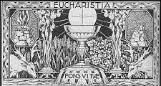

A Prayer for a Couple Preparing for Marriage
O Gracious and Loving Father, we humbly ask You to send Your blessings upon us as we prepare our hearts and souls for receiving Your holy Sacrament of Marriage. May we be thankful for all that You have already given to us. Help us, with Your grace, to prepare for the moment when You will unite us in the mystical grace of marriage. Grant that we may work together to be of one heart and of one mind, that we will be able to give due honor to each other, and that we may be united in love to You and to each other. When we are married, give us then the grace to live together in peace and holiness, as faithful members of Your Church, to be able to deny ourselves, and to be a mutual help, comfort, and support to each other, all the days of our life. If it be according to Your will, we ask that You bless us with children. If it be so, give us then the grace to be good and loving parents, and to raise our children in Your beautiful faith, which is a total gift from You. Bless us with health and strength, if it be Your will, and with whatever else Your good providence shall see to be best for our souls and bodies. Prepare us each and every day to grow in holiness, so that, when You see fit to call us from this life, we may together inherit eternal life in Your Heavenly Kingdom. We ask for all these things through Jesus Christ our Lord. Amen.

