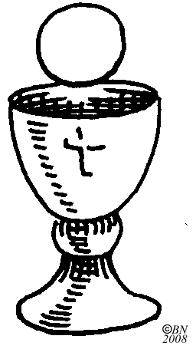

Liturgy of the Eucharist
Offertory We offer ourselves with the bread and wine.
Holy, Holy, Holy We join with the angels

Eucharistic Prayer
The priest takes the bread, says: Take this, all of you and eat of it, for this is my Body, which will be given up for you. Now it is no longer bread, but it is ___________!
The priest then takes the chalice with wine and says: Take this, all of you and drink from it, for this is the chalice of my Blood, the Blood of the New and Eternal Covenant, which will be poured out for you and for many for the forgiveness of sins. Do this in memory of Me. Now it is no longer wine, but it is ___________!
Memorial Acclamation
We p_____________ your d________, O Lord, and p__________ your r_________________, until you come again.

AMEN = _____ _______________

Our Father
Lamb of God

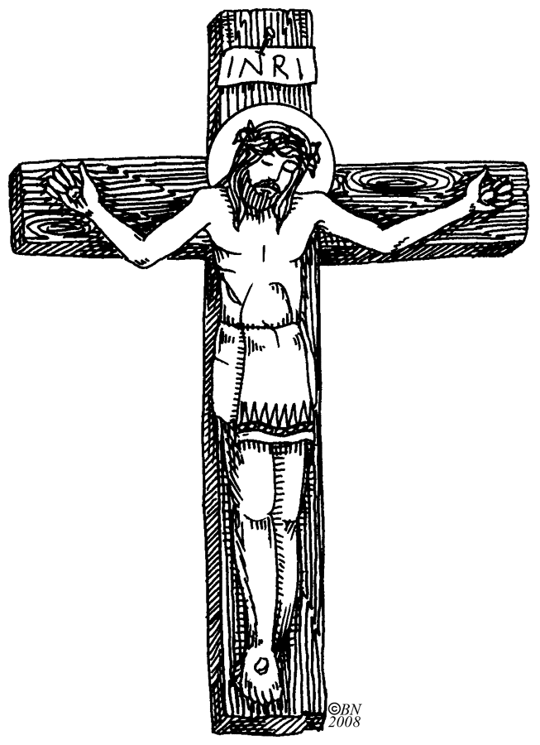

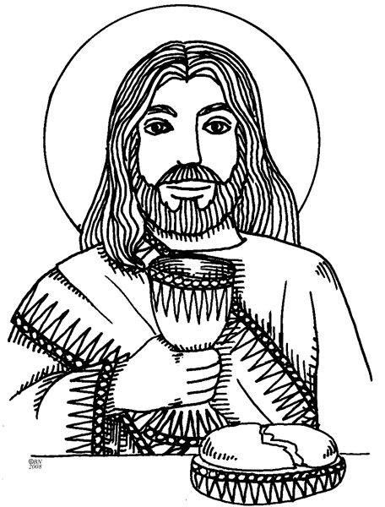

Concluding Rites

The Lord be with you.
______ ______ _______ ________

Go forth, the Mass is ended.

T__________ ____ ____ _______.

How can you go forth and show others that you love Jesus?
_____________________________
_____________________________
_____________________________
_____________________________
_____________________________
Holy Communion
When you can’t receive Communion, you can make a spiritual communion and receive Jesus spiritually in your heart. Write a prayer to Jesus, asking Him to come spiritually into your heart.
_______________________________________
_______________________________________
_______________________________________

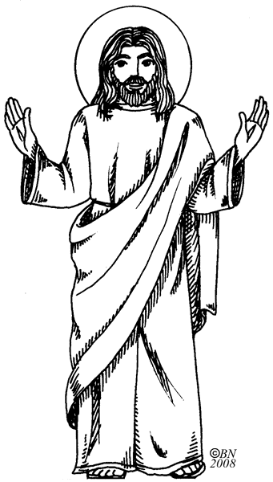

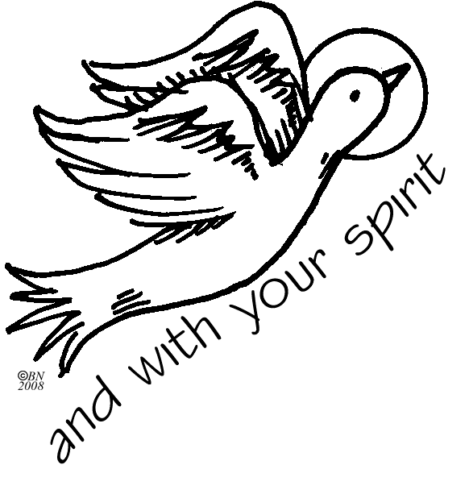
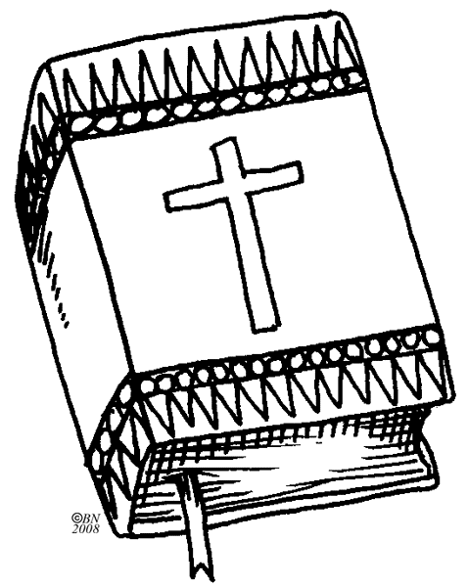
________ Reading (strfi)
Responsorial ________ (lspam)

GOSPEL = ____________ ____________
The Lord be with you
________ _______ ______ _________
A reading from the Holy Gospel according to N.
______, ___________, _________, ________
Glory to you, O Lord.
Your Word be on my ___________
And on my ____________
And in my _______________.

Father teaches us in the ____________. (limohy)

Creed
We say what we believe

Liturgy of the Word
Introductory Rites
Parts of the Mass

1. ___________________________________

2. ____________________________________

3. ____________________________________

4. _____________________________________

Entrance Procession and Song
Greeting

The Sign of the Cross takes us to the _________ and helps me to remember that __________ died for me.
Penitential Rite
Gloria

Opening Prayer

Draw a picture of the Blessed Trinity

