Instructions: Copy the page below and cut apart into strips. Have the children work in partners or small groups. Mix up the events and then have the children put them in the correct order.
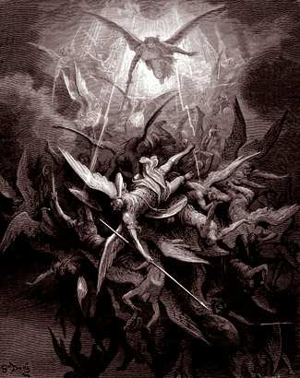 Some angels did not obey God and were sent to hell.

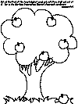 God told Adam and Eve not to eat of the fruit of the tree in the garden.

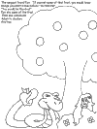 A snake told Eve to eat the forbidden fruit.

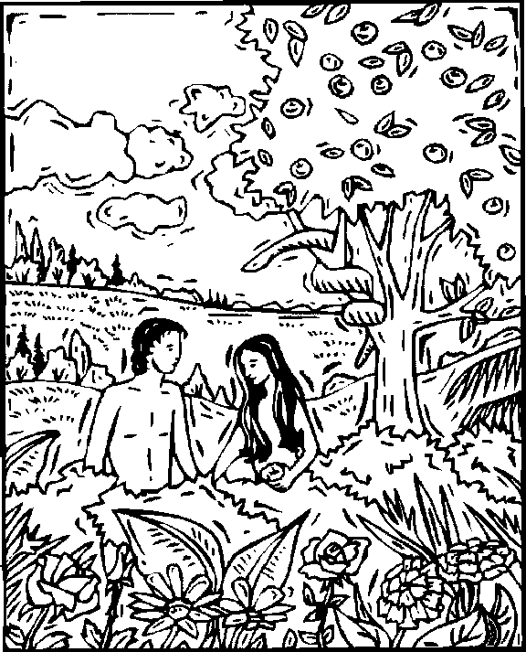 Eve ate the fruit and gave it to Adam to eat.

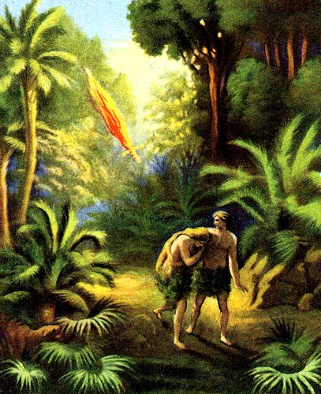 Adam and Eve had to leave the Garden of Eden.

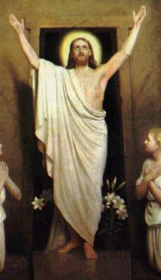 God promised to send a Savior.

