
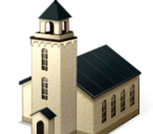

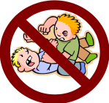

The Ten Commandments Name ________________
God’s Laws of Love
I can keep this commandment by ___________________ _________________________________________________
I can keep this commandment by ___________________ _________________________________________________
3. Remember to keep __________ the ______________ day.
I can keep this commandment by ___________________ _________________________________________________
I can keep this commandment by ___________________ _________________________________________________
I can keep this commandment by ___________________ _________________________________________________
2. You shall not take the ___________ of the ___________ your God in _________.
4. ______________ your ___________ and your _______________
5. You shall not __________.
1. I am the ________ your __________. You shall _____ have other _______ besides _________.



6. You shall not _____________
_____________.
I can keep this commandment by ___________________ _________________________________________________
I can keep this commandment by ___________________ _________________________________________________
I can keep this commandment by ___________________ _________________________________________________
I can keep this commandment by ___________________ _________________________________________________
I can keep this commandment by ___________________ _________________________________________________


7. You shall not _______________.


8. You shall not _____________ false ___________ against you _________________.


9. You shall not __________ your
neighbor's _________________.

10. You shall not __________ your neighbor's _________________.

