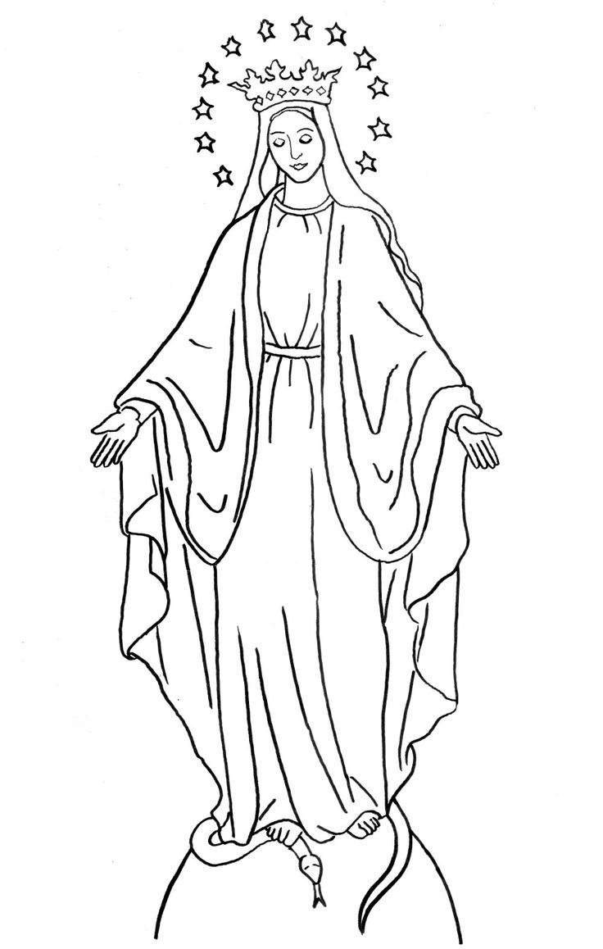

Things I love about my mother

How I can love my mother

Things I love about Mary, my mother in Heaven

Ways I can love my Mother, Mary.

