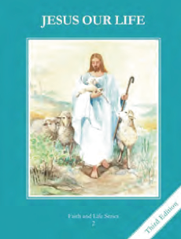
CCD GRADE 2: JESUS OUR LIFE
Chapter 1: Our Heavenly Father
• PREPARATION – How to Get Ready

Teacher’s Manual: pp. 1-11
Materials: Student Text, pictures of God the Father, pictures of places, a Bible
• PROCLAMATION – Main Theme

God created us so that we could be one with Him in Heaven. He gave us a human soul so that we could love as He loves.
• EXPLANATION – Content of Lesson

- God is our Father who made us. L1
  - Ask the children who made them. Then show pictures of God the Father eliciting from them different attributes of God as all loving, good, powerful, in Heaven, etc.
- God has given us a soul that loves, chooses right from wrong and will live forever in Heaven. L2
  - See balloon activity in Teacher Manual p4 Develop 1, 2, 3
- God is in Heaven and everywhere. He knows everything and watches over us. L3
  - Brainstorm different places and explain that God is in all these places.
- We can learn about God in the Bible. L4
  - Show children a Bible. Discuss how it is God’s Word and give examples of what it can tell us about God.
• APPLICATION – Connecting it to Students

- Play memory game – see pg 6 Develop 5
- Draw a picture of their favorite place and then draw God in that place
- Recall things they love to do with their earthly Father and then have them imagine them doing the same things with their heavenly Father.
- View “God’s Story” an overview of the Bible http://vimeo.com/85213037
• CELEBRATION - Conclusion

- Read a Psalm from the Bible or pray the Our Father slowly focusing on each phrase

