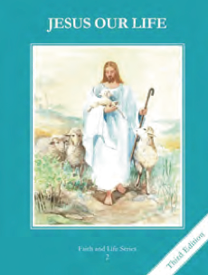
CCD GRADE 2: JESUS OUR LIFE
Chapter 10: Preparing for Our Savior
• PREPARATION – How to Get Ready

Teacher’s Manual: pp. 113-123
Materials: Bible Luke 1:26-38, Advent Wreath
• PROCLAMATION – Main Theme

God promised to send a Savior and prepared the way for His Son, Jesus.
• EXPLANATION – Content of Lesson

- God wants all His children to be happy in heaven forever. L1
  - Reflect with the children on why God made them.
- God promised to send a Savior, His own son, Jesus Christ. L1
  - Summarize God’s plan to send a Savior in the Old Testament
- God chose Mary to be the mother of His Son, the Savior. Mary was without sin and full of grace. This is called the Immaculate Conception. We celebrate the Feast of the Immaculate Conception on December 8. L2
  - Recall how God gave Mary a special gift
- God sent the angel Gabriel to ask Mary to be the mother of Jesus. This event is called the Annunciation which is celebrated on March 25. L3
  - Act out and read about the Annunciation
- Advent is the time of year when Christians prepare to celebrate the Savior’s coming. L4
  - Discuss the meaning of Advent
• APPLICATION – Connecting it to Students

- Have children put together or make their own Advent wreath
- Look up and read a few of the prophesies from Isaiah focusing on how God would send His Son
- Watch a clip of the Annunciation https://safeshare.tv/x/ss5d4d956f75835
• CELEBRATION - Conclusion

- Pray spontaneous prayers thanking Jesus for coming to be our Savior
- Pray the 1st Joyful Mystery of the Rosary

