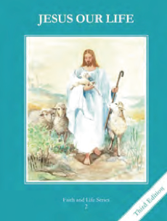
CCD GRADE 2: JESUS OUR LIFE
Chapter 12: The Holy Family
• PREPARATION – How to Get Ready

Teacher’s Manual: pp. 136-146
Materials: Bible –Lk 2:21-40, 41-52, Pictures of Jesus, Mary and Joseph
• PROCLAMATION – Main Theme

Jesus was the Son of God and the son of Mary. He was obedient. The Holy Family is a model for all families.
• EXPLANATION – Content of Lesson

- God is Jesus’ Father. L3
- Saint Joseph is the foster-father of Jesus and the husband of Mary. He was a carpenter and he is a great Saint. L1
  - Show pictures of St. Joseph and discuss his role in the Holy Family.
- Mary is the mother of Jesus and the wife of Joseph. She is the greatest of all the Saints. L2
  - Show pictures of Mary and discuss her role in the Holy Family
- The members of the Holy Family are Jesus, Mary, and Joseph. L3
  - Act out or list ways their family can be like the Holy Family.
- All Christians belong to the Holy Family because through Baptism Jesus is our brother, Mary is our Mother, and we can ask St. Joseph to be our friend and protector. L4
  - Spend time in prayer with each member of the Holy Family. Pray for their families.
• APPLICATION – Connecting it to Students

- Draw and picture of their family and the Holy Family noting how their family can imitate the Holy Family.
- Perform skits of a Day in the life of the Holy Family. (Can act out Presentation and Finding in the Temple in Luke’s Gospel as well)
- Make a card for their parents.
- Brainstorm ways they can be like Jesus in their family especially through their obedience.
- Pray the Litany of St. Joseph https://www.youtube.com/watch?v=TA0eHan7XI0
• CELEBRATION - Conclusion

- Pray for each member of their family

