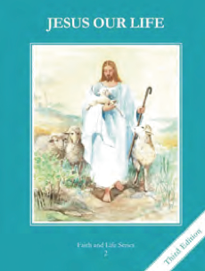
CCD GRADE 2: JESUS OUR LIFE
Chapter 14: Jesus our Teacher
• PREPARATION – How to Get Ready

Teacher’s Manual: pp. 163-173
Materials: Bible Lk 10:29-37 (Good Samaritan); Mt. 25:31-46 (Works of Mercy)
• PROCLAMATION – Main Theme

Jesus taught the law of love, and called us to love God and our neighbor.
• EXPLANATION – Content of Lesson

- The story of the Good Samaritan teaches us to love our neighbor. L1
  - Read, discuss and act out story
- Jesus told us to love our neighbor. When we love our neighbor, we are really loving Jesus. L2
- The seven Corporal Works of Mercy are:
1. Feed the hungry.
2. Give drink to the thirsty.
3. Clothe the naked.
4. Shelter the homeless.
5. Visit the sick.
6. Visit the imprisoned.
7. Bury the dead. L3
• APPLICATION – Connecting it to Students

- Apply to story of the Good Samaritan to life and discuss why others might not want to do good and are the people we sometimes don’t want to help
- Make a poster, comic strip or write about the Works of Mercy
- Make of list of ways to practice the Works of Mercy
- Write and perform skits for each
- Video: https://youtu.be/MF5DKVEQ7EA
• CELEBRATION - Conclusion

- Pray for the “neighbors” of the children.
- Pray a litany for those in need (see Conclude section at the bottom of TE p. 170)

