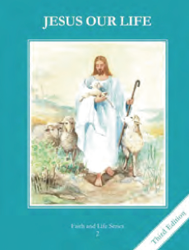
CCD GRADE 2: JESUS OUR LIFE
Chapter 15: Let Us Pray
• PREPARATION – How to Get Ready

Teacher’s Manual: pp. 175-185
Materials: Bible – Our Father Mt 6:1-16, Lk 11:1-4; Pharisee and Tax Collector Lk 11:9, 19, 10-24
• PROCLAMATION – Main Theme

Prayer is a relationship with God. Jesus teaches us to pray to God our Father. He hears us and responds.
• EXPLANATION – Content of Lesson

- Prayer is lifting our hearts and minds to God. L1
  - Act out the story of the Tax Collector and Pharisee comparing and contrasting the different attitudes of the men
- Jesus taught the disciples to pray the Our Father. L1
- The petitions of the Our Father. L2
  - Read the Our Father from the Bible and discuss what each line means
  - Have each child illustrate a different line of the Our Father
- God always hears our prayers and will answer them in the best way because He loves us. L4
  - Brainstorm different answers God might have for prayers (yes, no, wait)
• APPLICATION – Connecting it to Students

- Illustrations of the Our Father
- Give examples of ways He has answered prayers in Scripture or their life
• CELEBRATION - Conclusion

- Spend time in prayer with God

