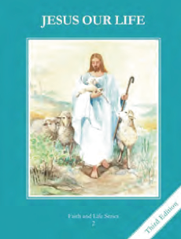
CCD GRADE 2: JESUS OUR LIFE
Chapter 17: Asking Forgiveness
• PREPARATION – How to Get Ready

Teacher’s Manual: pp. 201-211
Materials: Bible – Story of Prodigal Son Luke 15:11-32
• PROCLAMATION – Main Theme

Our Heavenly Father loves us and is always ready to forgive us. He calls us back to himself when we sin and intentionally break His laws and turn from Him.
• EXPLANATION – Content of Lesson

- Sin is a sad thing because it makes us lose God’s life of grace in us. L1
  - Give examples and non-example of sin. Have student give happy face/sad face.
- When we sin we are breaking God’s laws, turning away from Him, and hurting ourselves and others. L1
- God does not stop loving us when we sin. God always forgives us when we are sorry. L1
  - Have a person stand as “God” turned toward another person. Give examples of sin and have the person turn away. Have the person ask God to forgive them every time.
- In the story of the Prodigal Son, the father represents God. L2
  - Read and act out story.
- To receive God’s forgiveness, we must be sorry for our sins and ask for forgiveness. L3
  - Practice prayers of forgiveness especially the Act of Contrition
• APPLICATION – Connecting it to Students

- Complete Act of Contrition activity
- Define and discuss what the different words in the Act of Contrition.
- Practice praying the Act of Contrition
- Write prayers of sorrow.
- View the story of the Prodigal Son https://www.youtube.com/watch?v=kfDfMZ6MTJs
• CELEBRATION - Conclusion

- Pray a prayer of sorrow
- Imagine yourself being welcomed home by God like the Prodigal Son was by His father.

