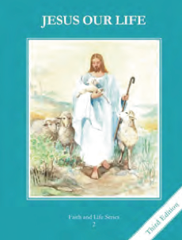
CCD GRADE 2: JESUS OUR LIFE
Chapter 18: Jesus Forgives
• PREPARATION – How to Get Ready

Teacher’s Manual: pp. 213-223
Materials: Bible – Healing of Paralytic Luke 5:17-32; Easter Sunday Night John 20:21-23
• PROCLAMATION – Main Theme

Only God can forgive sins. Jesus cured the sick and forgave sins. He gave the priest the power to forgive sins in the Sacrament of Confession.
• EXPLANATION – Content of Lesson

- The Sacrament of Penance is the Sacrament in which we confess our sins to a priest, our sins are forgiven, and grace is restored to our soul. L2, L4
  - Determine the background knowledge regarding Confession by asking questions like: Who can forgive sins?, How did Jesus show He was God?, How does God forgive our sins today?
- The Sacrament of Penance is also called Confession or Reconciliation. L2
  - Define and compare the different names of the sacrament
    - Confession- “to tell”- we tell our sins to Jesus through the priest
    - Reconciliation- “restore a friendship” – our friendship with God is restored
- Jesus made the disciples His first priests and gave them the power to forgive sins. God forgives sins through them, as the priests act in the person of Jesus. L2
  - Act out or read John 20:21-23
    - discuss the significance of this passage and what Jesus did
• APPLICATION – Connecting it to Students

- Act out the curing of the Paralytic from Luke’s Gospel showing how Jesus could forgive sins and cure others
- Write skits where students tell they are sorry, ask forgiveness and are forgiven
  - discuss how it feels to hear the words, “I forgive you” and link them to the words of Absolution in Confession
- Cut out activity cards and have the student ask each other the questions on them
- View link of the Luke 5 https://www.youtube.com/watch?v=HtPnD2FOFfk
• CELEBRATION - Conclusion

- Pray an Examination of Conscience and ask Jesus to forgive you for any sins you have committed.

