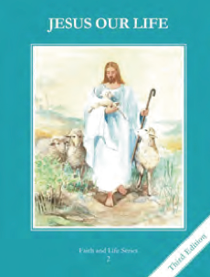
CCD GRADE 2: JESUS OUR LIFE
Chapter 19: Sacrament of Penance
• PREPARATION – How to Get Ready

Teacher’s Manual: pp. 225-235
Materials: Bible –Easter Sunday Night John 20:19-23
• PROCLAMATION – Main Theme

The steps to a good confession include examining your conscience, being sorry and deciding not to sin again, receiving the sacrament and doing penance.
• EXPLANATION – Content of Lesson

- The five steps to a good confession are:
1. Examine your conscience.
2. Be sorry for your sins.
3. Decide not to sin again.
4. Confess your sins to a priest.
5. Do the assigned penance. L1, L2, L3, L4
- The three effects of the Sacrament of Penance are:
1. Sins are forgiven.
2. Grace is restored to the soul.
3. Strength is given to be a good Christian. L4
• APPLICATION – Connecting it to Students

- Act out going to confession pointing out the steps and practicing the formula
- Illustrate the 5 steps to a good Confession
- Cut apart activity page and put steps in the proper order
- Make signs to hang up advertising the sacrament and telling of the effects of the Sacrament
- View clip of Brother Francis of the steps https://www.youtube.com/watch?v=eQTcUAWzF_U
• CELEBRATION - Conclusion

- Pray an Examination of Conscience and ask Jesus to forgive you for any sins you have committed.

