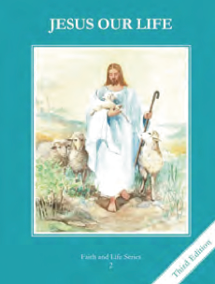
CCD GRADE 2: JESUS OUR LIFE
Chapter 2: The Blessed Trinity
• PREPARATION – How to Get Ready

Teacher’s Manual: pp. 12-23
Materials: Student Text, an apple or candle
• PROCLAMATION – Main Theme

The Blessed Trinity is three Persons in one God. Each of us is called
to share in God’s relationship of love.
• EXPLANATION – Content of Lesson

- There is only one God. There are three Persons in God. L2
  - View picture in Student text and discuss each person of the Trinity.
  - Use analogy of candle or light to articulate the unity and distinctness of the Trinity (see Teacher Manual p 16 Begin and Develop 3)
- The mystery of the three Persons in one God is called the Blessed Trinity. L2
- God the Father created Heaven and Earth. He is the First Person of the Trinity. L3
- God the Son is the Second Person of the Trinity. He came down from Heaven to become our Savior Jesus Christ. He taught us about God, died for our sins, and rose from the dead. L3
- The Holy Spirit is the Third Person of the Trinity. He helps us to pray, be good, and love God. L3
  - Complete Trinity Diagram
• APPLICATION – Connecting it to Students

- Share story of St. Patrick and the importance of teaching the Trinity when sharing the faith.
- Question the children using Teacher Manual p 18 Develop 2, 3, 4
- Complete Trinity Diagram – see Activity Book p 6
- Practice the sign of the Cross
- View “All Hail Adored Trinity” song https://www.youtube.com/watch?v=6Ou7ctmmK4c
• CELEBRATION - Conclusion

- Pray with a song about the Trinity or with each person of the Trinity

