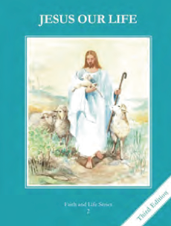
CCD GRADE 2: JESUS OUR LIFE
Chapter 20: Making Up For Our Offenses
• PREPARATION – How to Get Ready

Teacher’s Manual: pp. 237-247
Materials: Bible – Story of Zacchaeus Luke 19:1-10
• PROCLAMATION – Main Theme

Jesus redeemed us from our sins by His death on the Cross. We too can make up for our sins by doing penance out of love for Christ.
• EXPLANATION – Content of Lesson

- In the story of Zacchaeus, Zacchaeus made up for his sins by repaying people four times the amount of money he took from the. L1
  - Read and Act out the story of Zacchaeus
  - Discuss why he wanted to make up for his sins and how he did
- Forgiveness is when our relationship is made right with another after one is offended and the other says they are sorry. L3
  - Perform skits or make cartoon strips that show a person forgiving someone else
- Penance is making up for our sins, or a removal of our punishment. It restores what was lost due to sin. L3
- An act of penance can be a prayer, a work of mercy, a service to a neighbor, an act of self-denial, or the acceptance of our cross. L4
  - Brainstorm a list of penances the children can do
  - connect them to restoring what was lost when they sinned (saying a kind word to someone after they said something mean)
• APPLICATION – Connecting it to Students

- Draw or color a picture of Jesus on the Cross
- Encourage the children to hang their picture or a crucifix in their room to remind them of Jesus’ great love for them.
- Have the children pick a penance they can do during the week. Write it on a heart and present it to Jesus. During the following week, ask them how it went and if they could think of Jesus and do the act with love.
- View clip of the story of Zacchaeus https://www.youtube.com/watch?v=GHKMKWnJ92w
• CELEBRATION - Conclusion

- Meditate on a Crucifix and ponder how much Jesus loves them
- Pretend they are Zacchaeus and feel how eager the Lord is to forgive them when they sin

