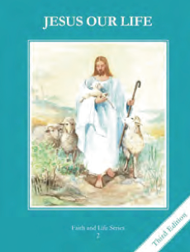
CCD GRADE 2: JESUS OUR LIFE
Chapter 21: The Good Shepherd
• PREPARATION – How to Get Ready

Teacher’s Manual: pp. 251-261
Materials: Bible – Good Shepherd Psalm 23, Lost Sheep Mt. 18:10-14, Good Shepherd John 10:1-21
• PROCLAMATION – Main Theme

Jesus is the Good Shepherd who laid down His life for his sheep. He calls us to be like Him practicing virtue.
• EXPLANATION – Content of Lesson

- He feeds, protects, leads, and strengthens us in the Sacrament L3
- Jesus lays down His life for us. L4
- We must be like Jesus the Good Shepherd. L4

- Practicing virtues helps us to be more like Jesus. L4
  - Define virtue as a habit of doing good
  - Brainstorm different virtues of Jesus and how we can be good like He is
- To be obedient means to do what pleases God and to obey cheerfully. L4
- To be truthful means to tell the truth and to never lie. L4
- To be forgiving means to love your enemies and forgive those who hurt you. L4
- To be prayerful means to say your daily prayers and to be mindful of God’s presence. L4
- To be merciful is to be kind to everyone, helpful and generous. L4

• APPLICATION – Connecting it to Students

- Act out scenarios of practicing these virtues and have children guess what virtue they are practicing
- Define each virtue and then play a matching game connecting words and examples
- Make signs calling others to practice a particular virtue
- Watch a shepherd call his sheep https://www.youtube.com/watch?v=Coq_grSFlNs
• CELEBRATION - Conclusion

- Slowly and prayerful read John 10 or Psalm 23 imaging Jesus coming to find His sheep
- Sing a song like “The King of Love my Shepherd is”
- Write a prayer to Jesus asking Him to help them be like Him

