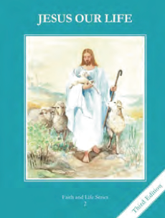
CCD GRADE 2: JESUS OUR LIFE
Chapter 23: Jesus Dies for Us
• PREPARATION – How to Get Ready

Teacher’s Manual: pp. 275-285
Materials: Bible – Passion of Jesus Mt 26:30-46, Mk 14:26-42, Lk 22:39-47
• PROCLAMATION – Main Theme

After the Last Supper, Jesus prayed in the Garden. He was arrested, crucified and died. He reconciled us with God.
• EXPLANATION – Content of Lesson

- After suffering the agony in the garden, being scourged, crowned with thorns, and made to carry the cross, Jesus was crucified on a hill called Calvary. L1, L2, L3
  - Retell the story of the crucifixion keeping in mind the age of the children
  - Ponder Jesus’s prayer and union with the Father’s will
- From the Cross, Jesus gave Mary to be our Mother. L3
  - Read the Gospel of John and have the children imagine the scene, thanking Jesus for the gift of His mother.
- Jesus died upon the Cross and opened the gates of Heaven to restore our friendship with God. L4
  - Recall the sin of Adam and Eve with it’s effects. Recall God’s great love for us.

• APPLICATION – Connecting it to Students

- Pray the Stations of the Cross
- Look at the different pictures for each station, telling the children the story and significance of each one.
- Activity: Have the children draw out the scene that is described in the box.
- Reflect on the good thief’s words, “remember me” as you view the video https://www.youtube.com/watch?v=nXP3oUatFt0

• CELEBRATION - Conclusion

- Pray a Divine Mercy Chaplet
- Meditation of the Death of Jesus

