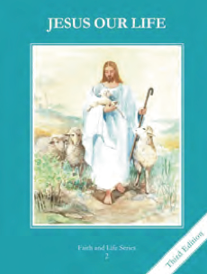
CCD GRADE 2: JESUS OUR LIFE
Chapter 25: The Sacrifice of the Mass
• PREPARATION – How to Get Ready

Teacher’s Manual: pp. 301-311
Materials: Bible – Last Supper Passages- Lk 22:14-23; 1 Cor 11:23-27; Mt 26:20-29; Mk 14:17-26
• PROCLAMATION – Main Theme

We go to Mass to worship God. It is the same sacrifice of Jesus on the Cross, offered to the Father for our sins, and made present to us in the Liturgy him as the Son of God.
• EXPLANATION – Content of Lesson

- At the Last Supper, Christ gave the Church the gifts of the Eucharist and the priesthood.
  - Jesus, said, “Do this in memory of me.” L1
- The Mass is the same sacrifice of Jesus on the Cross, offered to the Father for our sins, and made present to us in the Liturgy.
  - Define sacrifice. Discuss and color trifold picture
- We celebrate Mass on Sunday because this is the day that Jesus rose from the dead. L3
  - Brainstorm why we celebrate on Sunday. Explain that it’s a “little Easter”.
- Mass is offered to God to worship Him, thank Him, make up for our sins, and ask for His help. L4
  - Examine parts of the Mass to pertain to each.
- The Mass is the perfect prayer. L4
  - Explain why
• APPLICATION – Connecting it to Students

- Act out Last Supper
- Color trifold sheet (See activity page)
- Brainstorm how to keep Sunday holy
- Examine pictures of the Mass and Last Supper- Compare and contrast
- Listen to music reflecting on the beauty of the Eucharist https://www.youtube.com/watch?v=S8Sz0uFridc
• CELEBRATION - Conclusion

- Pray with the Last Supper scene and share about the gift of the Eucharist!

