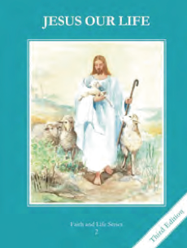
CCD GRADE 2: JESUS OUR LIFE
Chapter 26: What We Do at Mass
• PREPARATION – How to Get Ready

Teacher’s Manual: pp. 313-323
Materials: Bible Lk 24:27-31
• PROCLAMATION – Main Theme

We go to Mass to worship God. There are 4 main parts of the Mass.
• EXPLANATION – Content of Lesson

- The four major parts of every Mass are:
- Introductory Rites.
- Liturgy of the Word.
- Liturgy of the Eucharist.
- Concluding Rites. L1, L2, L3, L4
Recall the Main parts of the Mass and distinguish the most important parts.
- During the Consecration, the priest changes bread and wine into Christ’s Body, Blood, Soul, and Divinity. We offer ourselves to God. L3
  - Read about the Last Supper. Discuss how Jesus gave His life for us and how we can offer ourselves in union with Him.
  - Compare and contrast the host before the Consecration (looks, tastes like, is bread) and after the Consecration (looks, tastes like bread but is Jesus!)
- The ciborium hold the Body of Jesus and the chalice holds the Blood of Jesus. The plate is called the paten and the table is called the altar.
  - Look at and name the different things Father uses at Mass
- We go to Mass to be fed with God’s Word in the readings and Eucharist, and to receive God’s grace. L1, L2, L3, L4
• APPLICATION – Connecting it to Students

- Make a chart comparing the host before and after the Consecration
- Take a tour of the Sacristy and have a priest show the different vessels and vestments.
- Go through the Missalette and point out the words of Consecration and the different parts of the Mass.
- Complete Mass booklet
- Watch clips of the Consecration https://safeshare.tv/x/g7LpN13cDYI

• CELEBRATION - Conclusion

- Visit Jesus in Church and praise Him for the gift of the Mass

