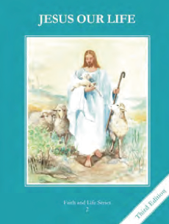
CCD GRADE 2: JESUS OUR LIFE
Chapter 27: Jesus Comes to Us
• PREPARATION – How to Get Ready

Teacher’s Manual: pp. 325-335
Materials: Bible Mt 19:13-15 (Call of Children), Jn 6:35-56 (Bread of Life Discourse)
• PROCLAMATION – Main Theme

Jesus comes to us in Holy Communion.
• EXPLANATION – Content of Lesson

- During the Consecration, the bread and wine become the Body, Blood, Soul, and Divinity of Jesus. This change is called transubstantiation. L1
  - Define and explain the change in the bread and wine at the Consecration
- The priest is the minister of the Sacrament of the Eucharist. L1
- The priest says, “This is My Body.” and “This is the chalice of My Blood.” to change the bread and wine into the Body, Blood, Soul, and Divinity of Jesus. L1
- The Eucharist is food for the soul because it gives us God’s life, it makes us grow as children of God, and it helps us to do what is right. L2
  - Compare and Contrast food for our bodies and food for our souls
- We should receive Holy Communion reverently on the tongue or in the hand. L4
  - Discuss, demonstrate and practicing receiving Communion properly and reverently (more in next lesson).
• APPLICATION – Connecting it to Students

- Make a chart comparing food for our bodies and food for our souls
- Brainstorm the different types of bread and places where you can find bread and connect why Jesus used bread and wine (can also connect to Passover)
- List the details of the Sacrament (words, matter that is used, minister, when Jesus gave it to us)
- Interview someone about their First Communion
- Write a letter to Jesus asking Him to come into your heart.
- Complete Activity page
- Watch song and recall what remembrance means (to make present) and what happens at Mass. https://www.youtube.com/watch?v=9oCNwIA6xLc
• CELEBRATION - Conclusion

- Imagine Jesus coming to you in Holy Communion or picture yourself as one of the children in the Gospel (Mt 19:13-15)

