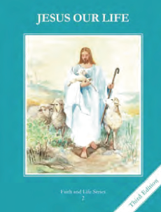
CCD GRADE 2: JESUS OUR LIFE
Chapter 28: Jesus, My Lord and My God
• PREPARATION – How to Get Ready

Teacher’s Manual: pp. 337-338
Materials: Bible Jn 20:24-29
• PROCLAMATION – Main Theme

Jesus comes to us in Holy Communion. We want to receive Him reverently.
• EXPLANATION – Content of Lesson

- The five steps for receiving Holy Communion worthily are:
- Have a healthy soul free from serious sin.
- Fast for one hour before Holy Communion.
- Know Whom we are receiving.
- Receive Him reverently.
- Thank Jesus for coming to us in Holy Communion. L1, L2, L3, L4
Describe each step
- We should offer ourselves to God before Holy Communion. L2
- We receive Jesus when we receive Holy Communion and He stays with us for a little while after Holy Communion. L3
- Receiving Holy Communion is the greatest thing we will ever do in this life. Ch.27-L2
  - Recall great things in life and elaborate why Holy Communion is even greater
• APPLICATION – Connecting it to Students

- Draw and discuss the steps to receiving Holy Communion
- Read and act out the story of St. Thomas focusing on his act of faith (My Lord and My God) and connect to what happens in Holy Communion (we too profess our faith even though we can’t see Him as St. Thomas did)
- Practice receiving Holy Communion properly and reverently
- Complete How to Receive Worksheet
- View Video https://youtu.be/_GEqnKMN1zE
• CELEBRATION - Conclusion

- Visit Jesus in Church and make a spiritual Communion. Talk to Him about how you want to receive Him.

