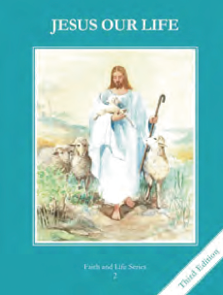
CCD GRADE 2: JESUS OUR LIFE
Chapter 29: Jesus Returns to the Father
• PREPARATION – How to Get Ready

Teacher’s Manual: pp. 351-361
Materials: Bible Acts 1:1-11 (Ascension) Jn 2:1-19 (Resurrection appearance to Peter)
Mt 28:16-20 (Great Commission)
• PROCLAMATION – Main Theme

Jesus ascended into Heaven 40 days after Easter and promised to send the Holy Spirit.
• EXPLANATION – Content of Lesson

- After the Resurrection Jesus remained on earth and taught His disciples for forty days.
  - Imagine what that was like to be with Jesus once more after He had Risen L1
- After the Resurrection Jesus gave His Apostles the power to forgive sins and told them to evangelize and baptize. L1
  - Act out the scene
- Jesus promised to send them the Holy Spirit. L4
- The event of Jesus rising into the sky and going up to the Father in Heaven is called the Ascension. L4
- Peter was made the first Pope.
- Jesus will come again at the end of time. L4
• APPLICATION – Connecting it to Students

- Make a timeline of Jesus’ life to review and discuss what happened after Jesus rose
- Read and discuss Jesus meeting the Apostles on the shore (Jn 21)
- Recall the Great Commission and the call to baptize. Act out skits or draw pictures of different situations (see TE p. 353)
- Question children about the Ascension (see TE p 358 Develop 1)
- Make comic strip about the Ascension (see activity)
- View video: https://youtu.be/0ozgKxpgYh0
• CELEBRATION - Conclusion

- Pray the 2nd decade of the Glorious Mysteries recalling the Ascension of Jesus

