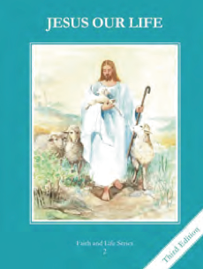
CCD GRADE 2: JESUS OUR LIFE
Chapter 3: God the Creator
• PREPARATION – How to Get Ready

Teacher’s Manual: pp. 25-35
Materials: Bible Daniel 3:40-43, 51-59
• PROCLAMATION – Main Theme

God is the Creator of Heaven and Earth. All creation is called to praise Him.
• EXPLANATION – Content of Lesson

- We call God “the Creator of Heaven and earth” because He made Heaven and earth out of nothing. L1
  - Compare and contrast “man-made” things and things God created (computer vs. trees)
- God created the world out of love and for our enjoyment. L1, L3
- List things you like that God created
- Ponder how He made them for us (see text pg. 18 para 1)
- Think about how all creation praises God
- Creation can teach us that God is powerful, beautiful, good, and wise. L1, L2
  - Brainstorm things (all levels of creation from rocks, plants, animals, humans, angels) and marvel how their qualities reflect God
    - Power of thunderstorms, beauty of flowers, wisdom of man, etc
- Man has been entrusted with the stewardship of creation. L3
  - Act out ways to take care of Creation
  - Tell about how God gave Adam the special task to care for the Garden of Eden
• APPLICATION – Connecting it to Students

- Feel the beat of your heart and think of the wonders of your body- how it works, it’s complexity and wonder contrast to something they’ve made
- Go on a nature walk and study the color of the sky, the grass and other things you find
- Draw pictures of things God created and praise him for them following Daniel’s model see pg 20 in student text
- Watch “God of Wonders” video and sing about the wonders of God’s creation
  - http://www.youtube.com/watch?v=_hJ1VUCBkuA
• CELEBRATION - Conclusion

- Pray your own Canticle of Daniel praising God for all things He has made.

