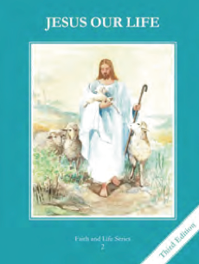
CCD GRADE 2: JESUS OUR LIFE
Chapter 30: The Coming of the Holy Spirit
• PREPARATION – How to Get Ready

Teacher’s Manual: pp. 363-373
Materials: Bible Acts 2:1-4 (Pentecost)
• PROCLAMATION – Main Theme

The Holy Spirit, the 3rd person of the Trinity, descended upon the Apostles at Pentecost.
• EXPLANATION – Content of Lesson

- The Holy Spirit is the Third Person of the Blessed Trinity. L1
- The Blessed Trinity is the mystery of one God in Three Persons. Ch. 2 L2
- The day on which the Holy Spirit came to the Apostles is called Pentecost. L31. After the Ascension, the Apostles stayed in the upper room with Mary, preparing for the coming of the Holy Spirit. L1
- 2. The Holy Spirit came upon the Apostles and filled them with strength and courage. L2
- 3. The Holy Spirit comes to us at Baptism. He helps man to pray and to love. He gives us grace.

• APPLICATION – Connecting it to Students

- Read about and look at pictures of Pentecost discussing what happened.
- Illustrate and list attributes of wind, fire and a dove then connect to the Holy Spirit discuss why it may be used as a symbol of Him.
- Make a poster featuring one of the seven Sacrament showing what the form and matter is (see TE p. 147)
- Make a chart with the symbols of each of the Sacraments (see TE p 370)
- Draw pictures of each Sacrament (see activity page)
- Watch as children explain what happened at Pentecost https://vimeo.com/105261521
• CELEBRATION - Conclusion

- Pray a prayer to the Holy Spirit

