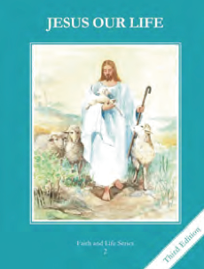
CCD GRADE 2: JESUS OUR LIFE
Chapter 33: Jesus is Always Present
• PREPARATION – How to Get Ready

Teacher’s Manual: pp. 399-409
Materials: Bible Mt 18:20 (“I will be with you always”) Mt 19:13 (Jesus blesses the children)
• PROCLAMATION – Main Theme

Jesus promised to remain with us always. When He ascended into Heaven, he keeps His promise by remaining with us in the Blessed Sacrament.
• EXPLANATION – Content of Lesson

- Jesus is with the Church through the Holy Spirit, in the Sacraments, in the teachings of the Pope and most especially in the Eucharist. L1
  - Recall Jesus’ promise to remain always with us and brainstorm how He keeps His promise
- We know Jesus is present in the Church because the sanctuary lamp is lit. L1
  - Go to Church to look at the Tabernacle and sanctuary lamp
- During Adoration and Benediction the priest places Jesus in the Monstrance. The rest of the time Jesus is in the Tabernacle in the Church. L1
  - Describe or participate in Adoration and Benediction
- Jesus waits for us to visit Him in the Blessed Sacrament; graces can be received by such visits. L2
- We are called to be reverent in the presence of the Lord. Such reverence includes church etiquette, such as genuflecting, silence in church, and devotion and attention at Mass. L4
  - Model and practice showing reverence in Church
• APPLICATION – Connecting it to Students

- Take a tour of the Church and point out the special items especially the Tabernacle and sanctuary lamp
- Read the Scripture passages and connect them to Jesus in the Eucharist
- Write a song or poem encouraging people to come to Adoration
- Spend time with Jesus in adoration
- Practice showing reverence in Church
- Make a chart illustrating the ways Jesus is with us always (see activity)
- View video of adoration and people praying in Jesus’ presence https://www.youtube.com/watch?v=fobBXDhVz-8
• CELEBRATION - Conclusion

- Visit Jesus and thank Him for being with us always!

