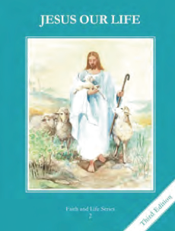
CCD GRADE 2: JESUS OUR LIFE
Chapter 4: God made us
• PREPARATION – How to Get Ready

Teacher’s Manual: pp. 32-40
Materials: Bible Gen 2, clay (optional)
• PROCLAMATION – Main Theme

God created out of love. He made us in His image and likeness so that we could love.
• EXPLANATION – Content of Lesson

- God made the first man and the first woman. They are called Adam and Eve. Later on, God made all the other people in the world. L1, L3
  - Make clay creations; marvel at creation of bodies
  - Retell/read the story of Gen 2; read text book pg 21
- Adam and Eve had original justice. They were completely happy. L2
  - Define characteristics of original justice
- God gave Adam and Eve a special gift called grace. Grace is God’s life in us. Grace makes us God’s children. L2
  - Discuss what grace is (a share in God’s life)
- God wants all His children to know Him, to love Him, and to serve Him in this life and to be happy with Him forever in Heaven. L3
  - Brainstorm and act out ways to know, love and serve God
- God has given each of us a Guardian Angel to guide and protect us. L4
  - Write a prayer/letter to your Guardian Angel thanking them for protecting you

• APPLICATION – Connecting it to Students

- Act out ways to know, love and serve God
- http://www.youtube.com/watch?v=3ch239kCT3Q
• CELEBRATION - Conclusion

- Practice one of the ways to know, love and serve God.

