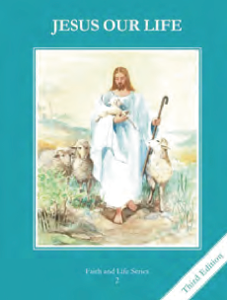
CCD GRADE 2: JESUS OUR LIFE
Chapter 6: Becoming a child of God
• PREPARATION – How to Get Ready

Teacher’s Manual: pp. 63-73
Materials: Symbols of Baptism- water, white garment, white candle, oil (to represent the Oil of Catechumens and the Sacred Chrism)
• PROCLAMATION – Main Theme

Baptism washes away Original Sin and makes us children of God.
• EXPLANATION – Content of Lesson

- Baptism is the Sacrament that makes us Christians, adopted children of God, and members of Christ’s Church. L2
- At Baptism, original sin and personal sin are washed away and grace is infused into the soul. L2
- Baptism makes it possible for us to please God and to go to Heaven. L2
- At Baptism, the Trinity comes to live in our souls; this is the life of God, grace. L2
- People who were faithful and good and went to Heaven when they died are called Saints. L4
  - Review the sin of Adam and Eve (Original Sin) and Grace (a share in God’s life)
  - Show the symbols used in Baptism (see TE p 66) and view video of a Baptism
  - Illustrate the effects of Baptism
    - Original and personal sin are washed away
    - Our soul is filled with grace
    - Baptism makes it possible to please God and go to Heaven.
    - At Baptism, we are born into God’s family, the Church.
    - At Baptism, the Trinity comes to live in our souls; this is the life of God, grace.
• APPLICATION – Connecting it to Students

- Act out or discuss how we can live out our Baptismal promises and keep our souls holy and pleasing to God
- Complete “Baptismal Covenant” worksheet
- Watch a Baptism http://www.youtube.com/watch?v=_LB5zL2apiw&feature=player_embedded

• CELEBRATION - Conclusion

- Renew your Baptismal Promises

