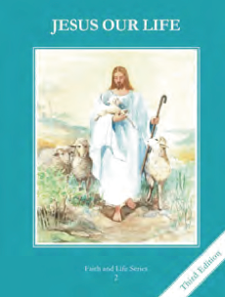
CCD GRADE 2: JESUS OUR LIFE
Chapter 7: Obeying God our Father
• PREPARATION – How to Get Ready

Teacher’s Manual: pp. 75-85
Materials: Bible – Noah Gen 6-9:18, Abraham Gen 12-22, David 1 Sam 16-17, 2 Sam 6-7
• PROCLAMATION – Main Theme

God promised to send a Savior. He prepared his people through Noah, Abraham and David.
• EXPLANATION – Content of Lesson

- Noah responded faithfully when God asked Him to build an ark in order to save His creation. L2
  - Review God’s promise of a Savior to Adam and Eve.
  - Retell the story of Noah emphasizing his faithfulness to God.
- Abraham responded faithfully when God asked him to sacrifice his beloved son, Isaac. God blessed him for his obedient love. L3
  - Act out the story of Abraham and Isaac emphasizing his obedience to God.
- God called David to be the king of His nation. David fought Goliath and became king. L4
  - Ponder the story of David and Goliath emphasizing his trust in God.
- Mary, Joseph, and Jesus are descendants from the family of David. L4
  - Connect the family of David with Jesus showing God’s plan
• APPLICATION – Connecting it to Students

- Make a timeline of various characters in Salvation History
- Brainstorm different ways to imitate the qualities of Noah, Abraham and David especially faithfulness, obedience and trust.
- Play “guess who” by naming an event or quality of a character and have the students guess who it is.
- Ponder the genealogy of Jesus and God’s plan to save us http://www.youtube.com/watch?v=kb9MmWKbdLI
- See activity book for more activities
• CELEBRATION - Conclusion

- Have the children recall their family tree and ponder how God planned from the beginning of time to send His Son Jesus to save them. Sing a hymn.

