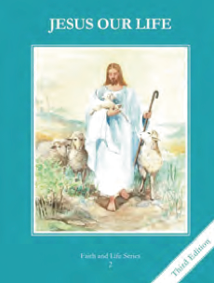
CCD GRADE 2: JESUS OUR LIFE
Chapter 8: God gives us His Laws
• PREPARATION – How to Get Ready

Teacher’s Manual: pp. 87-97
Materials: Bible – Story of Moses Ex 3-19:18
• PROCLAMATION – Main Theme

God gave the 10 Commandments to Moses and His people. They guide us to Heaven and teach us how to love God and others.
• EXPLANATION – Content of Lesson

- Abraham’s descendants became slaves in Egypt. Moses was sent to deliver his people. L1
  - Review Salvation History summarizing the people studied in Ch 7 adding the story of Moses
- God gave the Israelites the Ten Commandments so they could be happy and serve Him faithfully. L2
  - Recall laws that are good and how they help us. Connect that God also gave His people a way to keep His Covenant and follow Him.
- The first three commandments tell us how to love God. They are:
1. I am the Lord your God, you shall not have strange gods before Me.
2. You shall not take the name of the Lord you God in vain.
3. Keep Holy the Lord’s day. L3
- The next seven commandments tell us how to love and respect other people. They are:
4) Honor your father and mother.
5) You shall not kill.
6) You shall not commit adultery.
7) You shall not steal.
8) You shall not bear false witness against your neighbor.
9) You shall not covet your neighbor’s wife.
10) You shall not covert your neighbor’s goods. L3
  - Discuss and act out each commandment showing ways to keep it and to break it.
• APPLICATION – Connecting it to Students

- Complete Activity sheet
- Give students simple scenarios and have them decide which commandment they are keeping or breaking.
- Have they children pick one or two commandments that they can practice following during the week.
- View the call of Moses and ponder how God calls them to be part of His family. http://safeshare.tv/w/xaKZKLvUVu
• CELEBRATION - Conclusion

- Pray an Examination of Conscience based on the 10 Commandments
- Thank God for the gift of His Laws of Love!

