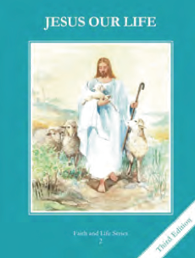
CCD GRADE 2: JESUS OUR LIFE
Chapter 9: I Choose to Love God
• PREPARATION – How to Get Ready

Teacher’s Manual: pp. 101-111
Materials: Bible
• PROCLAMATION – Main Theme

Jesus gave us the two great Commandments. When we break them, we commit a sin.
• EXPLANATION – Content of Lesson

- The first Great Commandment Jesus gave is to love God with all your heart, all your soul, all your strength, and all your mind. L1
  - Retell or act out the story of the rich young man having the students guess which commandment is the greatest.
- The second Great Commandment Jesus gave us is to love your neighbor as yourself. L1
  - List Commandments that show love of God and love of neighbor
- An action that is wrong and done on purpose is a sin. An accident is not a sin. L4
  - Classify examples between accidents and sin
- Mortal sins are very bad, big sins which kill the life of grace in our soul. L4
  - Define and give examples
- Venial sins are small sins that make God sad and lead us to commit bigger sins. L4
  - Define and give examples
• APPLICATION – Connecting it to Students

- Have the student write skits or draw pictures of them showing love for God and others
- Sort Choices – see Activity chart
- List 3 things for a sin to be Mortal
- Discuss the difference between Mortal and Venial Sin
- View video and discuss expressions and connect to Confession and how Jesus always loves us https://www.youtube.com/watch?v=5rnOT2eUBB0
• CELEBRATION - Conclusion

- Make an Examination of Conscience and pray an Act of Contrition
- Praise God for His great love!

