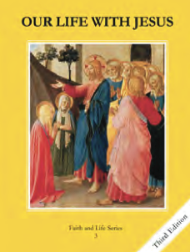
CCD GRADE 3: OUR LIFE WITH JESUS
Chapter 12: Purity and Truth
• PREPARATION – How to Get Ready

Teacher’s Manual: pp. 137-146
Materials: Student textbook, items for 5 Senses activity
• PROCLAMATION – Main Theme

We keep God’s commandments to respect our bodies and the bodies of others, to not want or take what is not ours, and to be honest.
• EXPLANATION – Content of Lesson

- The sixth and ninth commandments teach us to respect our bodies and the bodies of others.
- Our bodies are a gift from God. He gave us our five senses.
- Our bodies are sacred because they are temples of the Holy Spirit. God’s life dwells in our souls.
- To covet means to want what is not ours.
- The seventh and tenth commandments teach us not to take or want what is not ours.
- To respect someone’s property means not to take what isn’t yours, not to break or damage others’ property, and to replace or pay for property that is accidentally broken or damaged.
- The Eighth commandment teaches us to be honest; we shouldn’t lie or cover up our mistakes.
• APPLICATION – Connecting it to Students

- After 5 Sense activity: What if we didn’t have our bodies? Could we enjoy all of these things? Why did God give you your body?
- 7th and 10th commandments: Think of something you own that is important to you. How would you feel if someone took it or broke it?
- Activities:
  - The Five Senses- Discuss how our bodies are an important gift from God
  - 7th and 10th commandment skits- Students act out and judge different scenarios.
- Video: https://youtu.be/gURuDn6lxMw
• CELEBRATION - Conclusion

- Pray for those who do not have things they need, like food or shelter.

