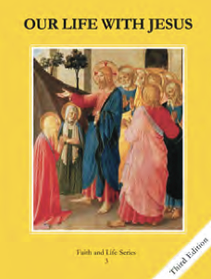
CCD GRADE 3: OUR LIFE WITH JESUS
Chapter 13: God’s Tender Mercy
• PREPARATION – How to Get Ready

Teacher’s Manual: pp. 153-163
Materials: Student textbooks and Activity books, pictures of shepherds and sheep, Holy Bible
• PROCLAMATION – Main Theme

God is all-merciful; He desires to forgive us and restore our relationship with Him.
• EXPLANATION – Content of Lesson

- God’s merciful love is endless. It is greater than any sin man can commit. God can forgive any sin and wants to reconcile man to Himself.
- There is no sin that God cannot forgive.
- Mortal sins are very serious sins that kill God’s life in our souls.
- Venial sins are smaller sins that diminish God’s life in our souls and make us inclined to commit mortal sins.
- Jesus taught man about the forgiveness of sins through healing, stories, and through the forgiving example of His life.
- Jesus is the Good Shepherd
- Jesus forgives our sins today through the priest in the sacrament of Reconciliation.
- Peter and Mary Magdalene are examples of repentant sinners who were shown mercy and compassion.
- Peter denied Jesus and was forgiven after the Resurrection.
- Mary Magdalene washed Jesus’ feet.
• APPLICATION – Connecting it to Students

- Discussion questions: What is the worst sin you can think of? Can God forgive that sin? Is there any sin God cannot forgive?
- Activities:
  - Demonstrate turning away from God when we sin.
  - Act out Peter’s denial and forgiveness.
  - At end of lesson, review with Activity Book p. 51
- Video: To show a real example of a shepherd calling her sheep- https://www.youtube.com/watch?v=Holr54eF4LY
• CELEBRATION - Conclusion

- Closing prayer: Act of Contrition

