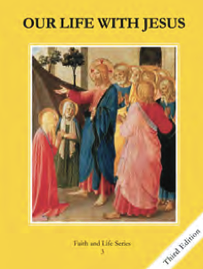
CCD GRADE 3: OUR LIFE WITH JESUS
Chapter 15: The Christ Child is Born
• PREPARATION – How to Get Ready

Teacher’s Manual: pp. 177-187
Materials: For activities: Clear cups, dirt, water/sink, Christmas music
• PROCLAMATION – Main Theme

God chose Mary to play a special part in His plan to save humankind. Mary’s “yes” to God allowed Him to become man (Jesus) in order to save us from sin.
• EXPLANATION – Content of Lesson

- The Annunciation is when God, through the angel Gabriel, invited Mary to be the mother of His Son.
- Mary said “Yes” and conceived by the power of the Holy Spirit, yet remained a virgin.
- This was the beginning of Jesus’ human life.
- God becoming human in order to save mankind is called the Incarnation.
- The Immaculate Conception was when Mary was conceived in the womb of her mother.
- From the first moment of her life, Mary was free from Original Sin.
- We celebrate Jesus’ birth on Christmas.
- Jesus was born in a stable in Bethlehem.
- He wished to be poor so he could teach us to be humble and not to try and find happiness in money and the pleasures of the world.
• APPLICATION – Connecting it to Students

- Discussion questions (about Nativity):
  - Where was Jesus born?
  - Did he have a lot of things? Were Mary and Joseph rich?
  - Why do you think God chose to come into the world in this way?
- Activity: The Immaculate Conception (explanation with cups and dirt)
  - Christmas musical chairs
- Video: The Annunciation https://www.youtube.com/watch?v=VrYvuYwPAvU
  - This short clip can provide a visual for the students to understand the conversation between Mary and the Angel Gabriel at the Annunciation.
• CELEBRATION - Conclusion

- Sing “Silent Night” or another Christmas song about Jesus’ birth and Mary.

