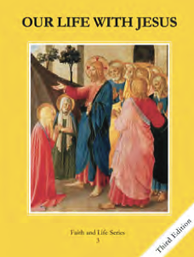
CCD GRADE 3: OUR LIFE WITH JESUS
Chapter 2: God Created the World
• PREPARATION – How to Get Ready

Teacher’s Manual: pp. 11-20
Materials: paper plates, markers, scissors, other items to decorate masks
• PROCLAMATION – Main Theme

God created everything good and with a purpose, and His purpose for us is to know, love, and serve Him in this life and be happy forever with Him in heaven. God also created us with free will to choose to follow His plan or not.
• EXPLANATION – Content of Lesson

- God is the Creator of all things and everything He created is good.
- Story of Creation
- “Create” vs. “Make”
- God gives us a free will to know, love, and serve Him. We can choose good and avoid evil.
- God’s plan for us
- Choosing evil (sin)
- Choosing good (following God’s plan)
- God desires that all of us go to Heaven.
- Our choices in this life have consequences.
- We choose heaven or hell by the way we live.
• APPLICATION – Connecting it to Students

- Have students write or share their favorite created thing, and identify how God created it for good.
- Question: What is our purpose? How did God create us for good?
- Activities:
  - Activity book p. 5
  - Make props to act out Creation story
- Video: https://safeshare.tv/x/ss5d518800e8ee3
• CELEBRATION - Conclusion

- Closing prayer: Invite children to thank God for His creation, especially for creating us and giving us the opportunity to be happy with Him forever.

