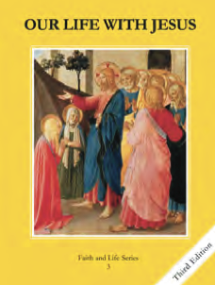
CCD GRADE 3: OUR LIFE WITH JESUS
Chapter 3: Learning About God
• PREPARATION – How to Get Ready

Teacher’s Manual: pp. 21-30
Materials: Bibles (enough for students to at least share), Student textbooks p 17-18
• PROCLAMATION – Main Theme

From the world around us and by using our reason, we can know God exists. He also reveals Himself through His son Jesus, in the bible, and through the Church Jesus established.
• EXPLANATION – Content of Lesson

- From the world around us and by the use of our reason, we can know God exists.
- Creation reflects God’s perfections/characteristics
- God reveals Himself to us more directly when He sends His only Son.
- The best way to get a message to someone is in person.
- Jesus teaches us about God through parables and by example (since he is God).
- God became man so that man could better understand God.
- God reveals Himself in the bible.
- God inspired all of the different authors of the bible.
- The Old Testament shows how God was with His chosen people.
- The Gospels tell us what Jesus said and did.
- The Pope and bishops teach and guide the Church today.
- They make sure God’s true message is passed on.
• APPLICATION – Connecting it to Students

- Discussion question: “Do you think it’s possible for every person in the world to know God? What if no one ever told them?”
- Activity: Telephone
- Video: https://www.youtube.com/watch?v=V9IOhGPrRvY Parable of the Sower; the different soils are the different ways the we receive God’s Word. You can read Mark 4:1-20 which explains the meaning of each soil.

• CELEBRATION - Conclusion

- Closing prayer: Guide students to ask God to help them know Him better, and then invite them to tell Him one thing about their day.

