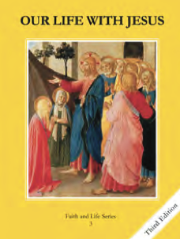
CCD GRADE 3: OUR LIFE WITH JESUS
Chapter 4: The Promise of a Savior
• PREPARATION – How to Get Ready

Teacher’s Manual: pp. 31-40
Materials: Student Textbook, yarn, scissors, *optional construction paper and markers/colored pencils
• PROCLAMATION – Main Theme

Adam and Eve fell from God’s grace (Original Sin) and passed this sin on to all people. However, God promised a savior, Jesus, who died for our sins so we could go to heaven. We receive this grace (God’s life in us) through Baptism.
• EXPLANATION – Content of Lesson

- God created angels. Some of the angels refused to serve God and became evil.
- “Angel” means messenger
- God created archangels (Michael, Gabriel, Raphael)
- Every person has a guardian angel to protect them
- Because of Adam and Eve’s sin, all people inherited Original Sin.
- The Fall of Man (Genesis 3)
- Life before sin vs. life after
- Because of sin, grace was lost. We need grace to be able to go to Heaven.
- Even though Adam and Eve sinned, God promised to send a Savior (Jesus).
- Jesus died on the cross to save us from sin and death.
- Jesus’ death gives us the grace we need to restore our relationship with God.
- Through baptism we receive sanctifying grace so that we can go to Heaven.
  - Baptism is the sacrament Jesus gave us so we could receive his gift of grace.
  - We can still choose to sin after baptism, which causes us to lose grace and hurt our friendship with God.
• APPLICATION – Connecting it to Students

- What do you know about angels? What have you seen at a baptism?
- Activity: Mortal and Venial Sin, Optional: draw a before and after picture of the Garden of Eden, or act out a baptism.
- Video: https://youtu.be/JpNe6UNgwXA
• CELEBRATION - Conclusion

- Closing prayer: Act of Contrition

