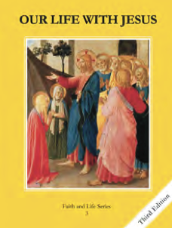
CCD GRADE 3: OUR LIFE WITH JESUS
Chapter 6: The Prophet Moses
• PREPARATION – How to Get Ready

Teacher’s Manual: pp. 63-73
Materials: Book- Student Textbook, pictures/props to represent things Egyptians worshiped (Nile River, frogs, cattle, sun, first born sons)
• PROCLAMATION – Main Theme

God desired to free His people from slavery and establish a covenant with them. He chose to work through Moses, sending plagues on the Egyptians, leading the Hebrew people across the Red Sea, and giving them the Ten Commandments.
• EXPLANATION – Content of Lesson

- God chose Moses to free His people from slavery.
- Pharaoh became jealous of the Israelites and forced them into slavery.
- God spoke to Moses in the burning bush and told him to demand Pharaoh let His people go.
- God sent plagues.
- The Egyptians worshiped many things as gods.
- All of the plagues were sent to prove that God is the one, true God and He is more powerful than the things the Egyptians worshiped.
- The plagues were: the Nile turned to blood, frogs, gnats and flies, cattle dying, boils, hail, locusts, darkness, and the death of the firstborn sons.
- Passover
- At the Passover meal, the Israelites had to sacrifice and eat a lamb (the Paschal lamb).
- Jesus is the new Paschal lamb because he was sacrificed on the cross and we receive him in the Eucharist. He frees us from slavery to our sins.
- God gave Moses the Ten Commandments that would make His people happy and holy.

• APPLICATION – Connecting it to Students

- What would you do if you were Moses and God told you to free His people from slavery?
- Activities: Plague charades, Follow the Pillar
- Video: https://youtu.be/-9ki5FycGyQ
• CELEBRATION - Conclusion

- Pray for students’ intentions.

