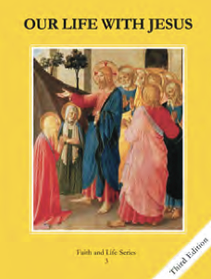
CCD GRADE 3: OUR LIFE WITH JESUS
Chapter 7: God’s Laws of Love
• PREPARATION – How to Get Ready

Teacher’s Manual: pp. 75-85
Materials: Student textbook, activity book (optional), Ten Commandments written on slips of paper (mixed with non-commandments), bibles
• PROCLAMATION – Main Theme

God gave us the Ten Commandments to help us love Him and others. Jesus summarized the Ten Commandments in the great commandment of Love.
• EXPLANATION – Content of Lesson

- God gave us the commandments because He loves us.
- If we obey them, they will nourish our souls and help us to live in right relation with God and others.
- The first three commandments help us to love God.
- The next seven commandments help us to love our neighbor.
- Jesus summarizes the Ten Commandments with the great Commandment of Love.
- The first and greatest commandment: Love the Lord your God with all your heart, with all your soul, and with all your mind.
- The second greatest commandment: love our neighbor as yourself.
- If we follow God’s commandments, God promises us eternal joy with Him in Heaven.
• APPLICATION – Connecting it to Students

- Students give examples of how to keep and break each commandment.
- Activity: Commandment Search, Act out scenarios
- Video: https://safeshare.tv/x/aX28nAB4S7A This video explains the Israelites’ journey across the Red Sea and in the desert, where God cared for them and gave them the Ten Commandments.
• CELEBRATION - Conclusion

- Closing prayer: Our Father

