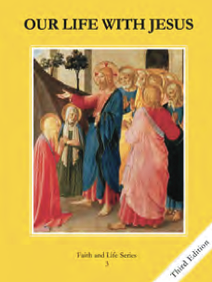
CCD GRADE 3: OUR LIFE WITH JESUS
Chapter 9: Loving God Most of All
• PREPARATION – How to Get Ready

Teacher’s Manual: pp. 101-111
Materials: Student textbooks, newspapers, magazines, scissors
• PROCLAMATION – Main Theme

The first and second commandments help us love God above anything else, and use His holy name with love and respect.
• EXPLANATION – Content of Lesson

- The first commandment tells us not to put anyone or anything above God.
- We are created to know, love, and serve God in this world and to be happy with Him forever in the next.
- Some examples of false gods or things people are tempted to put above God are money, clothes, toys, friends, and pleasure.
- Superstition is believing that created things have powers that truly possess.
- The second commandment tells us to speak about God in a reverent way.
- Names are important. Saying God’s name gets His attention and speaks of His presence.
- Saying God or Jesus’ name when we are surprised or angry are ways of breaking the Second Commandment.
- The way we address someone tells about the relationship. Jesus taught us to call God “father” or “daddy.”
• APPLICATION – Connecting it to Students

- Opening discussion question: “Why do we love God?”
- In false god activity, have students identify examples and explain how their example is meant to be used for good.
- Activity: Magazine/newspaper hunt for false gods
- Video: (and how it applies)
• CELEBRATION - Conclusion

- Closing prayer: Pray in the way Jesus taught us, by calling God, “Our Father…”

