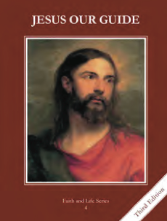
CCD GRADE 4: JESUS OUR GUIDE
Chapter 1: The Fall of Man
• PREPARATION – How to Get Ready

Teacher’s Manual: pp. 3-11 (for background information)
Materials: Powerpoint (look at ahead of time, or print for information and when technology is not available)
• PROCLAMATION – Main Theme

God created us in love. He wants us to be with Him so much that He promised to send a Redeemer even after Adam sinned.
• EXPLANATION – Content of Lesson

- God created us in His image to love Him.
- Discuss days of creation using graphic from powerpoint
- Creation Ladder—angels, humans, animals, plants, rocks (inanimate objects)
- we are created as children to love our Heavenly Father; act out difference between a slave and a child
- Original sin: Adam and Eve were tempted and chose to disobey God.
- Read story of the fall in text or Gen 3:1-19
- Sin of disobedience and distrust of God
- By sinning, Adam separated himself from God’s love and lost grace. We are born without sanctifying grace.
- Natural, preternatural, supernatural gifts (use powerpoint for explanation)
- Grace is necessary for salvation; Baptism restores sanctifying grace
- Sanctifying grace=God’s life in us
- God does not abandon us because of our sin, but promised to send us a Redeemer.
  - Gen 3:15 (use powerpoint for explanation)
• APPLICATION – Connecting it to Students

- How are you like Adam and Eve? How are you unlike Adam and Eve?
- How/when do you distrust God?
- Act out difference between a slave a child and the Fall of Adam and Eve
- Find statues of Mary around the church/parish hall; look for other symbols of creation and our relationship to the Father in stained glass or other objects. End by making a visit to Jesus in the Blessed Sacrament.
- Video—Creation sequence from Encounter Series by Mark Hart; pictures of the days of creation, ending with humans created in the image and likeness of God. http://safeshare.tv/w/gweqRltjqd
• CELEBRATION - Conclusion

- End with a prayer thanking God for sending Jesus as our Savior and Redeemer. Pray the Our Father.

