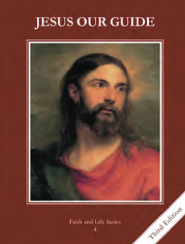
CCD GRADE 4: JESUS OUR GUIDE
Chapter 11: Life in the Promised Land
• PREPARATION – How to Get Ready

Teacher’s Manual: pp. 128 – 132 for person background
Materials: For the fall of Jericho, set up a wall of boxes (large or small) or any other materials you want with the class.
• PROCLAMATION – Main Theme

Joshua, Samson, and Ruth trusted God enough for Him to do great things for the Israelites. When we trust God, He can do great things for us.
• EXPLANATION – Content of Lesson

- Joshua trusted God and led the Israelites into the Promised Land by crossing the Jordan River.
- Observe the PowerPoint map of the Exodus route. Read 1st three paragraphs of p. 52.
- The first city they conquered was Jericho. Act out the fall of Jericho with your wall.
- Samson sacrificed himself so that he could save the Israelites from the Philistines.
- Have a few students begin acting out the story of Samson. After each paragraph in “God Sends Samson” (p 53) is read, act out what just happened.
- Discuss how God used Samson to protect his people.
- Discuss special gifts the students have and how they can be used for God.
- Ruth trusted God and through her descendants came King David.
- Depending on time, watch short (3 min) http://safeshare.tv/w/PLwjJUNRaR or long (15 min) http://safeshare.tv/w/CqpEdCOOTu version of Ruth’s story.
- Discuss. Why might Naomi have told Ruth she could leave? Why did Ruth stay? Did she believe in God or want to believe in God? How did Ruth meet Boaz? Why is it important that Ruth and Boaz were married? What very important people were their children and grandchildren? (Jesse, David, and Jesus)
• APPLICATION – Connecting it to Students

- Discuss special gifts the students have and how they can be used for God.
- Fill out maps of Israel with cities, bodies of water, and 12 tribes.
- Video: 3 min “Ruth and Naomi” or 15 min “Ruth – A Faithful Woman”
• CELEBRATION - Conclusion

- Pray the St. Michael the Archangel prayer for protection, just as Joshua, Samson, and Ruth trusted God enough to protect their people.

