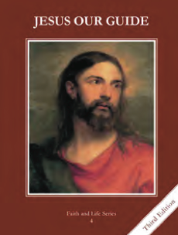
CCD GRADE 4: JESUS OUR GUIDE
Chapter [12]: [A King for God’s People]
• PREPARATION – How to Get Ready

Teacher’s Manual: pp.140-147
Materials: flag or shield/coat of arms template
• PROCLAMATION – Main Theme

God listened to the people’s request for a king and Saul was anointed the first king by Samuel
• EXPLANATION – Content of Lesson

- Samuel was called by God and followed His will.
- Read or act out the story of Hannah praying for a son and dedicating him to God.
- Read or act out the story of God calling Samuel and Samuel’s response of “Speak, Lord, your servant is listening.”
- The Ark of the Covenant was captured because the Israelites were using it like a good luck charm instead of with faith.
- Review superstition, how God is all-powerful and that we need to have faith and trust in Him.
- Read or act out the story of the Ark of the Covenant being captured and what happened to the Philistines when they had the Ark (1 Sam 4-6).
- Lead a discussion with questions from the powerpoint
- The Israelites asked God for a king and by doing so rejected God as their king.
- Share with the students the fact that the Israelites asked Samuel to anoint a king for them. Read the story from the text or from Scripture (1 Sam 8)
- Discuss the questions on the PowerPoint
- Discuss why it is more important to be faithful to God and follow His commands even if it means being different from everyone else. Use the scenarios on the PowerPoint as desired.
- Saul was made king, but later stopped following God’s will. God rejected him as king and gave the kingdom to David.
- Review what the Israelites wanted from a king
- Read, tell or act out the story of Saul’s disobedience (student text p. 58; 1 Sam 15:1-31)
- Discuss Saul’s kingship—questions on PowerPoint
• APPLICATION – Connecting it to Students

- Discussion questions on PowerPoint; scenarios about living for Jesus even if it means being different
- Make a coat of arms or a flag representing the Kingdom of God. Have the students explain the symbols.
- http://safeshare.tv/w/rVoztkDqUE Chris Stefanik speaking on how Christ needs to be the king of our lives.
• CELEBRATION - Conclusion

- Have the children close their eyes and imagine that they are with Jesus. Direct them to say to God in their heart, “Speak, Lord, your servant is listening” and quietly wait for a response. As their minds wander, have them repeat the phrase again.

