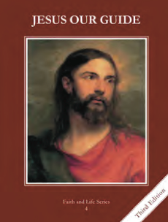
CCD GRADE 4: JESUS OUR GUIDE
Chapter 13: King David
• PREPARATION – How to Get Ready

Teacher’s Manual: pp. 156-161
Materials: PowerPoint, butcher paper
• PROCLAMATION – Main Theme

God chose David to be the next King of Israel; he sinned, but repented and God forgave him.
• EXPLANATION – Content of Lesson

- David loved God, followed His will, and defeated Goliath.
- Read, review, act out the story of David defeating Goliath—1 Sam 17 or from the textbook.
- Point out David’s virtues, especially his trust in God and courage; discuss how the children can live those virtues in their own lives.
- David trusted, loved and obeyed God. Saul did not.
  - Recount how Saul was disobedient to God 1 Sam 15:10-23 or text p. 58; show pictures
- Saul became jealous of David, who was now a commander in his army.
- Discuss that Saul became jealous because the people loved David more than him
- Put events in order of what led to David becoming king.
- Lead discussion with questions.
- David became king and conquered Jerusalem. He brought the Ark of the Covenant into his city after offering sacrifices to God.
- Act the events of the Ark of the Covenant being brought into Jerusalem.
- Lead discussion with questions related to bringing the Ark into Jerusalem.
- David sinned greatly, but God forgave him.
- Discuss the sin of David and what David did differently from Saul when he sinned; David repented. 2 Sam 11-12 or student text p.63
- Read Psalm 51; listen to Create in Me (Psalm 51)—Sovereign Grace Music
• APPLICATION – Connecting it to Students

- Discussion of how we can live David’s virtues
- Act out the story of David and Goliath as told on page 61 of the text. Cut a piece of butcher paper 9 feet tall and trace a fourth-grader on it to show the difference between David and Goliath.
- https://youtu.be/mM7UAM0xsN4 Create in Me (Psalm 51)—Sovereign Grace Music; have them read Psalm 51 from the Bible first and then explain that this psalm was written after David sinned and that the song is based on Psalm 51
• CELEBRATION - Conclusion

- Review that David wrote the Psalms and choose one to pray. You could divide the children into 2 sides and have them alternate by verse or stanza. An option is Psalm 51.

