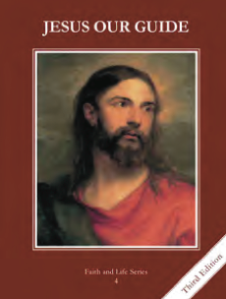
CCD GRADE 4: JESUS OUR GUIDE
Chapter 14: King Solomon and the Promise of a New King
• PREPARATION – How to Get Ready

Teacher’s Manual: pp. 166-173
Materials: Powerpoint
• PROCLAMATION – Main Theme

King Solomon was very wise, but did not use his wisdom well as he became older. God sent Isaiah to tell the people to repent because the Savior was coming.
• EXPLANATION – Content of Lesson

- Solomon was granted great wisdom by God, and with it he was able to judge rightly.
- Act out the story on page 65 of the textbook.
- Discuss wisdom and wisdom scenarios from the Powerpoint.
- Solomon built a great Temple to God which housed the Ark of the Covenant.
  - Discuss what was in the Ark of the Covenant. Where is God especially present today?
- As Solomon grew older he let his many wives draw him into idolatry.
- Use the Powerpoint to discuss Solomon’s foolishness.
- Isaiah used his gift of prophecy to warn God’s people to repent and to tell them about the Messiah.
- Read the first column of page 67 and act it out.
- Tell students that Isaiah prophesized that there would be a Messiah, or Savior.
- The Messiah or Savior would be different from Solomon because He would be poor, rejected, beaten and killed. He would be a suffering servant and would always be faithful to God.
- Read the last paragraph of page 67 and into page 68. Discuss the Messiah’s characteristics.
• APPLICATION – Connecting it to Students

- Discuss wisdom scenarios. Discuss how we should treat our bodies as temples of the Holy Spirit.
- Take a tour of the church with all its holy places. Compare to Solomon’s temple.
- https://youtu.be/834B6Lu5CKQ “Sophia” by Matt Maher. Sophia is the Greek word for wisdom.
• CELEBRATION - Conclusion

- Pray Solomon’s prayer to God for wisdom, found in the Book of Wisdom, Chapter 9. Short form would be Wisdom 9:1-5, long form could be Wisdom 9:1-18

