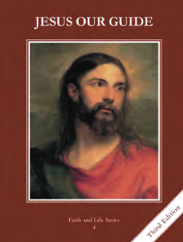
CCD GRADE 4: JESUS OUR GUIDE
Chapter [15]: [The Final King]
• PREPARATION – How to Get Ready
Teacher’s Manual: pp. 178-183
Materials: white paper, crayons, markers, etc. to make posters
• PROCLAMATION – Main Theme
Jesus is the new and final King.
• EXPLANATION – Content of Lesson

- Israel became divided because of sin and invaded by foreigners. They were taken into captivity, but were eventually released and returned to Israel, awaiting their Savior.
- Review the important vocabulary for the lesson
- Describe how the tribes divided because of sin
- Use the timeline to discuss the major events of the Babylonian exile
- Use “What would it have been like” (from PowerPoint) to discuss the situation
- John the Baptist was the greatest of all the prophets and he helped the people prepare for the Savior, the final King
- Review the mission of the prophets and some of the prophets from the Old Testament
- Describe John the Baptist as the last and greatest prophet
- Look up Scriptures related to John’s miraculous birth and preaching about Jesus
- Use the PowerPoint slide to discuss why God became man and that John was preaching repentance and reconciliation.
- John baptized Jesus
- Read and act out Matthew 3:13-17
- Discuss why Jesus was baptized if He is sinless
- Watch video of the Baptism of Jesus
  - Many Israelites had a hard time accepting Jesus as King because he was poor and did not seek or accept worldly power
  - Discuss the expectations of the Jews and the reality of what Jesus preached
  - Discuss Jesus’ work on earth and have the students give examples

- John the Baptist proclaimed the Kingdom of God. Have the students be modern-day John the Baptists by advertising the Kingdom of God.
- Video: Baptism of Jesus from the Miracle Maker, https://youtu.be/2-K6GzRn-w4
• CELEBRATION - Conclusion
- Sing "To Jesus Christ, Our Sovereign King"

